Wayne William Weidert, Sr.
October 15, 1942 - January 12, 2020

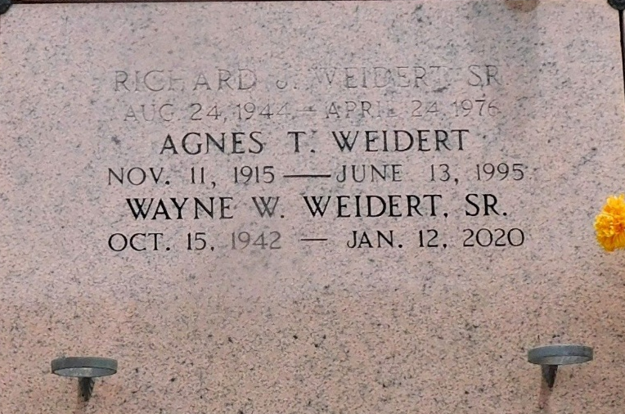
Photo by Mary Agnes Hammett

Wayne William Weidert, Sr. passed away Sunday, January 12, 2020, at the age of 77. He was native of New Orleans, LA and resident of Reserve, LA.
Beloved husband of 26 years, to Nell Patterson Weidert. Loving father of Wayne (Amy) Weidert Jr., Yvette (Bryan) Madere, Heather (Julius) Duncan, and Stepfather of Becky (David) Junker, Ed Jones, Steven (Michelle) Jones, and Candy Ward. Grandfather of Joshua (Haley) Weidert, Amanda (Jacob) Duhe, Kristyn Madere, Kaitelyn Madere, Lance Bowen, Landon Bowen, Angela (Gus) Mire, Morgan (Richard) Davis, Lynzie (Morgan) Regira, Kayla (Daniel) Sanders and Joey Ward. Great Grandfather of Lawson Regira. Brother of George Weidert and the late Greer Weidert, Richard Weidert, and Dale Weidert. Son of the late Arthur Weidert and Agnes Trosclair Weidert.
Relatives and friends are invited to attend a visitation at Millet-Guidry Funeral Home, 2806 West Airline Highway, LaPlace on Friday, January 17, 2020 from 9:00 a.m. to 11:00 a.m. followed by a Memorial Mass at 11:00 a.m. Inurnment will immediately follow the service at St. Peter Cemetery, 1550 LA-44, Reserve.

Millet-Guidry Funeral Home, LaPlace, Louisiana
January 15, 2020

