David Wempren
December 22, 1958 – February 16, 2015

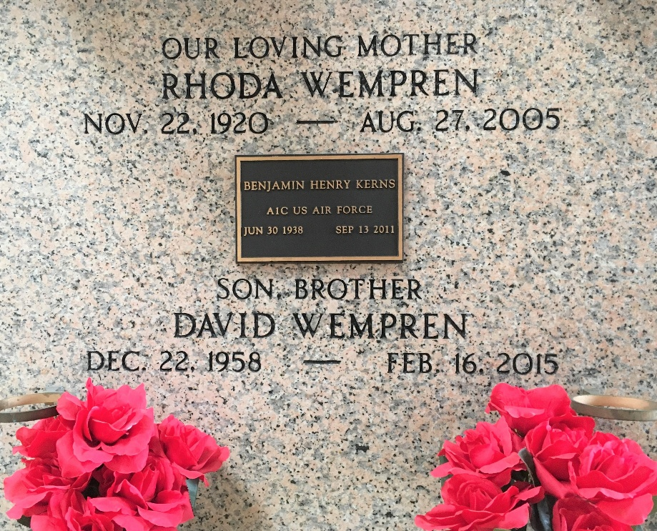
Photo by Team T-Lo

David Wempren passed away on Monday, February 16, 2015 at the age of 56. He was born in New Orleans and was a longtime resident of Reserve.

Beloved husband of Mona Duhe Wempren. Son of the late Lawrence and Rhoda Weir Wempren. Brother of Lizzie Wempren, Lawrence Wempren, Jr. (Theresa) and the late Bruce Wempren.
Relatives and friends are invited to attend the Funeral Service at First Baptist Church of LaPlace, 120 Ormond Blvd., LaPlace on Thursday, February 19, 2015 at 11:00 a.m. Visitation will begin in church at 10:00 a.m. Interment will be held at a later date in St. Peter Cemetery.

Millet-Guidry Funeral Home, LaPlace, Louisiana

