Rhoda (Weir) Wempren
November 22, 1920 – August 27, 2005

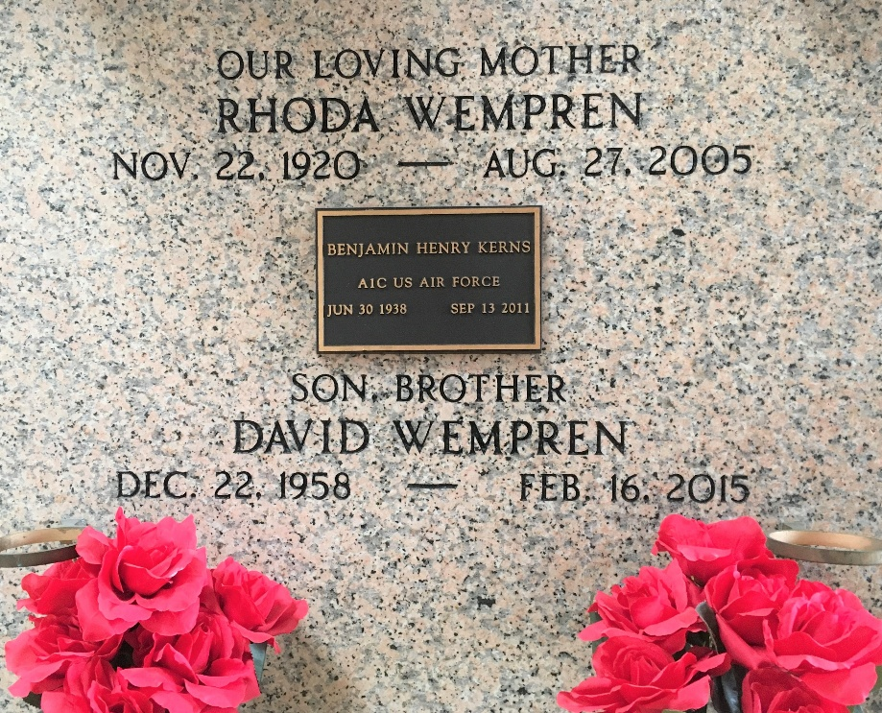
Photo by Team T-Lo

Rhoda W. Wempren, On Saturday August 27, 2005 At 6:10 Am.
Beloved Wife Of The Late Lawrence Wempren, Sr. Mother And Mother-In-Law Of Lizzie, Lawrence Jr. And Theresa, David And Mona Wempren, And The Late Bruce Wempren. Grandmother Of Crystal Wempren And Great Grandmother Of Amber And Miranda.
Daughter Of The Late Jim And Mattie Weir. Age 84, A Native Of Tulsa, Oklahoma And A Resident Of Reserve, Louisiana For The Past 52 Years.
Relatives And Friends Of The Family Are Invited To Attend Services. Visitation At Millet-Guidry Funeral Home, 2806 West Airline Hwy., Laplace On Sunday, August 28, 2005 From 8:00 Am Until 10:00 Am. Followed By Religious Services In The Funeral Home Chapel At 10:00 Am. Burial In St. Peter Cemetery In Reserve.

Times Picayune, New Orleans, Louisiana
August 28, 2005

