Lorraine (Leche) Wheeler
January 13, 1928 – October 21, 2008

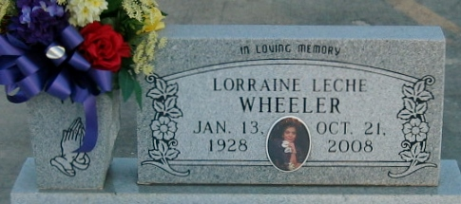
Photo by Bobby

Lorraine M. Wheeler on Tuesday, October 21, 2008 at Ochsner Foundation Hospital, Jefferson, LA.
Daughter of the late Nicholas and Felecia Madere Leche. Beloved wife of Allen Wheeler. Beloved mother of Renee Wheeler, Tammy L. (Cassius, Sr.) Williams and Kenrick Wheeler. Sister of Ruby L. Porter, Claudia L. (Cleveland, Sr.) Farlough and the late Hubert, Alvin, Leroy, Walter and Clyde Leche. Also survived by 3 grandchildren, Corinne and Cassius Williams, Jr. and Christopher Smith, 3 aunts, Irene Madere, Alia Madere and Vera Leche, a host of nieces, nephews, cousins, other relatives and friends. A native and resident of Reserve, LA, formerly a resident of Park Forest, IL.
Relatives and friends of the family, also priest and parishioners of Our Lady of Grace Catholic Church and all neighboring churches are invited to attend the Mass of Christian Burial at Our Lady of Grace Catholic Church, 772 Highway 44, Reserve, LA, on Saturday, October 25, 2008 at 11:00 AM. Father Joseph Rodney, SSJ, Celebrant. Interment St Peter Cemetery, Reserve, LA. Visitation at the above named church from 9:00 AM until Mass time. SERVICED BY ROBOTTOM.

Times Picayune, New Orleans, Louisiana
October 24, 2008

