Ella P. White
March 12, 1894 – February 25, 1995

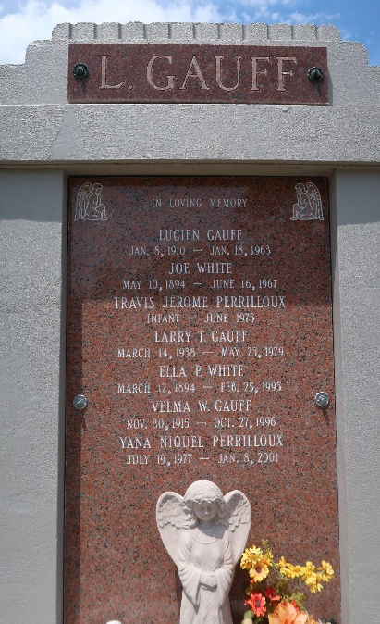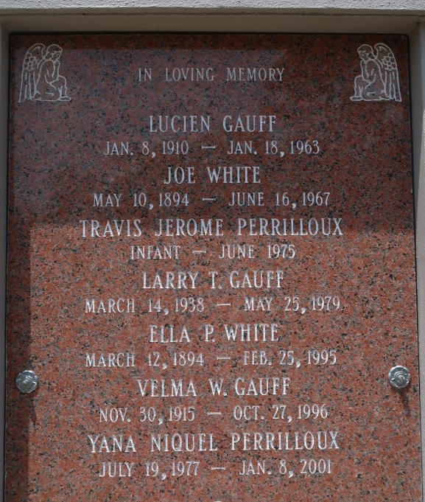
Photo by Bobby

Ella P. White, A Former Homemaker, Died Wednesday At River Parishes Hospital In Laplace. She Was 100. Mrs. White Was Born In Wilson And Lived In Garyville For 82 Years. She Was A Member Of Mount Zion No. 1 Baptist Church.

Survivors Include Two Daughters, Velma Gauff Of Garyville And Evelyn Bickham Of Chicago; And Seven Grandchildren.

A Wake Will Be Held Today At 7 P.M. At Mount Zion No. 1 Baptist Church On Little Hope Street In Garyville. The Funeral Will Be Monday At 11 A.M. Burial Will Be In St. Peter Cemetery In Reserve. Baloney Funeral Home Is In Charge Of Arrangements.

Times Picayune, New Orleans, Louisiana
February 26, 1995

