Athanas Otere Williams
October 30, 1927 – September 7, 2011

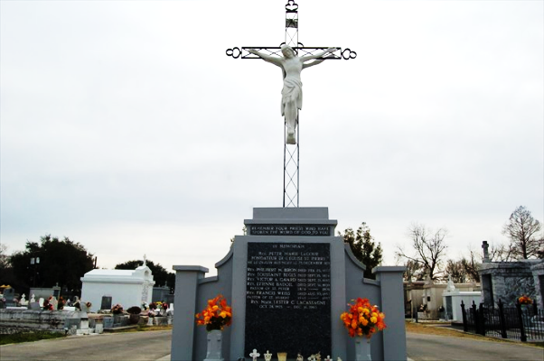

Boy Athanas Otere Williams passed away on Wednesday September 7, 2011 at 7:45 pm at the age of 83.
Beloved husband of Anne Williams and by first marriage to Sarah Schiro Curtis. Father of Berlyne Williams Trosclair. Stepfather of Jerry Underwood, Phillip Cambre (wife Connie) and Pierre Cambre (wife Barbara). Grandfather of Todd, Jr., Tasha and Tonia Trosclair and the late Tate Trosclair. Step grand-father of Bonnie Sue Schuetz, Terri Thompson, Royce Underwood, Jessica Andrus, Christopher, Adam, Amber and Noah Cambre.
Son of the late Athanas Eliase Williams and the late Bertha Mause Williams. Brother of Mary "Ketsy" Schiro, Earl "Sonny" Williams and the late Betty Williams Deem and James "Jake" Williams, Sr. Also survived by 11 step great grandchildren and numerous nieces and nephews.
A native and resident of Reserve, LA. A veteran of the United States Army, Fire Chief of the Reserve Fire Department and police officer for the St. John the Baptist Parish Police Department. Sole proprietor of Boy's Auto Repair, a retired school bus driver for St. John the Baptist Parish and a member of the V.F.W.
Relatives and friends are invited to attend services. Visitation at St. Peter Catholic Church, 1550 Highway 44, Reserve, La., on Saturday, September 10, 2011 from 10:00AM until 12:00 Noon, followed by a Mass at Noon. Burial in St. Peter Cemetery, Reserve. Arrangements by Millet-Guidry Funeral Home, LaPlace.

The Times-Picayune, New Orleans, Louisiana
Sep. 10, 2011

