Charles Louis Williams
April 6, 1949 – July 16, 2022

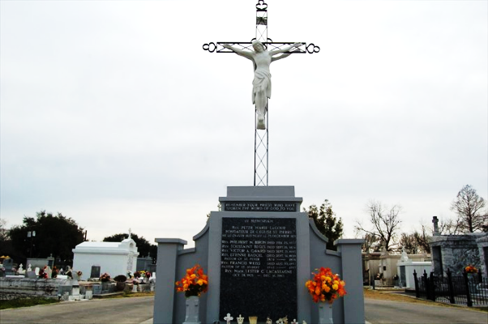

Charles "Chuck" Williams passed on July 16, 2022, at the age of 73.
Father of Charles "Patrick", Bryan, and Dwayne Williams. Former husband of the late Betty Huber. Son of the late Helen and Larry Williams Sr. and brother of the late Larry Williams Jr. (Cynthia). Survived by brothers Leo, Julian (Aimee), and Tommy (Amelia) Williams. Sisters Julia Remondet (Tim), Catherine Reynolds, Tammy Milioto (Timmy), and Lisa Hoover (Steven). Beloved Grandfather and Uncle.
Loving referred to as "Chucky Baby" he had a vibrant personality, was the life of the party, and loved dancing, Saints & LSU Football, and messaging his family and friends on social media.
Services will be held on Friday, July 29, 2022, at St. Peter Catholic Church in Reserve. Visitation from 9:00 am to 11:00 am followed by Mass and burial at St. Peter Cemetery.

The Times-Picayune, New Orleans, Louisiana
July 22-29, 2022

