Cynthia Ann (Walker) Williams
June 7, 1947 – April 7, 2013

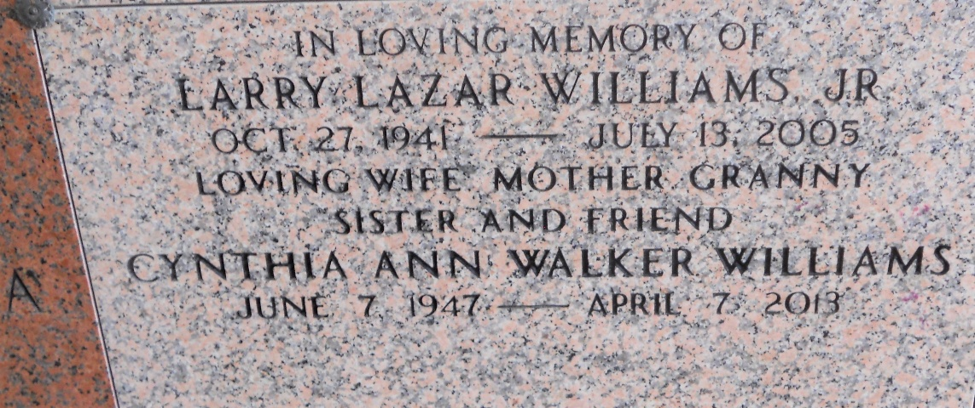
Photo by Team T-Lo

Cynthia Walker Williams, age 65 years, departed this earth on Sunday, April 7, 2013.
Beloved wife of the late Larry Williams, Jr., Mother of Jason Williams (Raelene), Daughter of the late Thomas "Vernon" Walker and Ceola Schexnayder Walker, Sister of Melody Walker Yoes (Gene), Grandmother of Grant Thomas and Gabrielle Rae Williams.
She was an LSU graduate with a teaching degree and enjoyed attending LSU football games with family and friends. She also loved to paint and eat out with her friends.
Visitation will be at Millet-Guidry Funeral Home, 2806 West Airline Hwy., Laplace, LA on Thursday April 11, 2013, from 9:00am to 11:00am followed by Religious Services in the Funeral Home Chapel at 11:00am. Burial in St. Peter Cemetery, Reserve, LA.

The Times-Picayune, New Orleans, Louisiana
April 8-10, 2013

