Leroy Dallas Williams
November 17, 1939 – March 5, 2015

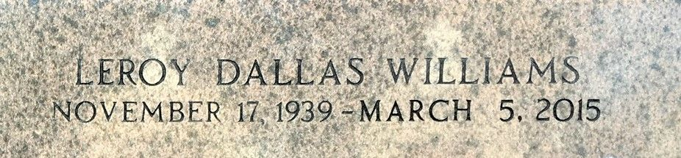
Photo by Team T-Lo

Brother Leroy Dallas Williams departed this earthly life on March 5, 2015.
Husband of Regina Hebert. Father of Jerrold R. Williams. Grandfather of Deron Martell, Jerrold, Jr., Isaiah, and Jeremiah Williams. Brother of Stella M. Davis. Also survived by other relatives and friends. Age 75.
Current and former employees and students of St. John the Baptist Parish Public Schools, St. John the Baptist Parish Public Library, Greater New Plymouth Rock Baptist Church, Southern University Alumni Federation and Association, staff at Ochsner Medical Center (West bank), staff of Capgemini Consulting Services are invited to attend the funeral service at First Community Antioch Baptist Church, 10860 Highway 3125, in Lutcher, Louisiana on Saturday, March 14, 2015 at 11:00 a.m. Visitation will be held from 9:00 a.m. until the time of the service. Reverend Ferdinand Gaines, officiating. Burial in St. Peter Cemetery Reserve, La
Services Entrusted to Hobson Brown Funeral Home 134 Daisy St. Garyville, La 70051 985-535-2516
The Times-Picayune, New Orleans, Louisiana
Mar. 9 to Mar. 13, 2015

