Mercee Marie (Duhe) Williams
September 3, 1886 – May 5, 1973

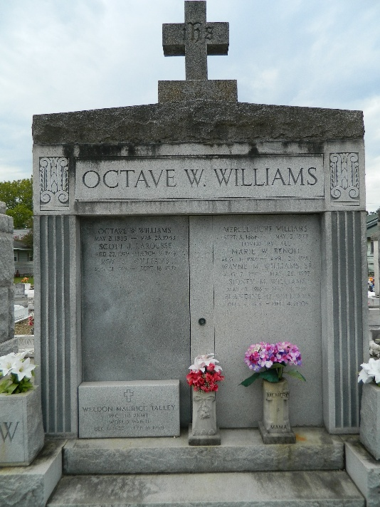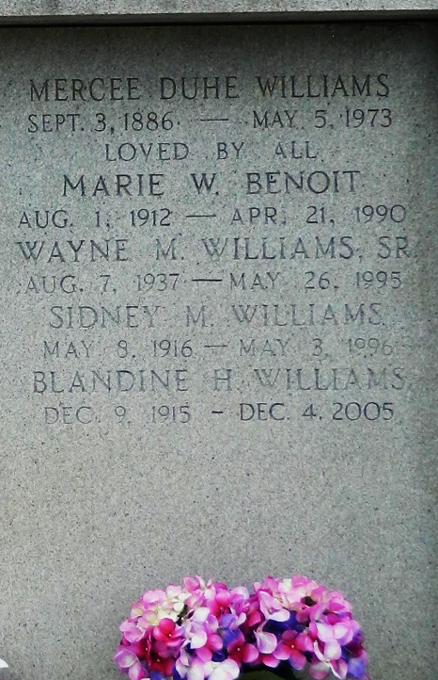
Photo by Team T-Lo

Age 86 years, a native and resident of Reserve, Louisiana. Wife of the late Octave Williams and mother of Antoine (A. O.) Williams of Thibodaux, Louisiana, Mrs. Marie W. Benoit and Sidney Williams of Reserve, Lloyd (Pappy) Williams of Baton Rouge, Roy J. Williams of California, Allen Williams, Mrs. Weldon (Marguerite) Talley, Mrs. Wilson (June) Daigle, and Mrs. Louis (Audrey) Bienvenu, all of Metairie, Louisiana.

She was the daughter of the late Jacques Duhe and Felicie Keller and sister of Virginia Duhe Tregre, Helen Duhe Brown, Gladys D. Trosclair and Leonie Duhe.

Services were Monday, 7 May 1973, at St Peter Church, Reserve, with interment in St Peter Cemetery.
The Times-Picayune, New Orleans, Louisiana
May 7, 1973

