Mildred (Schexnayder) Williams
December 8, 1914 – September 10, 1993

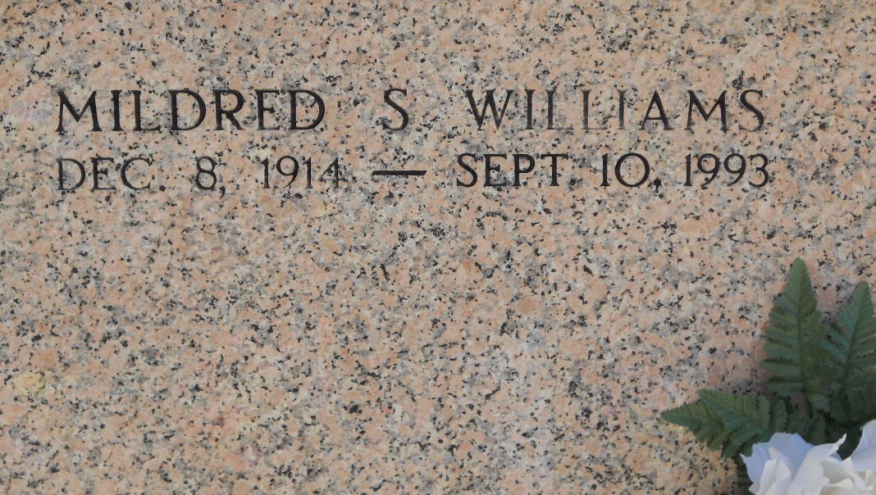
Photo by Team T-Lo

Mildred Schexnayder Williams died Friday 10 Sep 1993 at 10:00 pm at age 78 years. She was a native of Garyville, Louisiana, and a resident of Metairie, Louisiana, for the past 49 years.

She was the wife of the late Nicholas (Speed) Williams and the daughter of the late Maurice and Lydia Lambert Schexnayder. Sister of Margaret Schexnayder, Hilda Schiro and the late Earl, Lloyd and Fr Lester Schexnayder.

Services were Monday 13 Sep 1993 with interment in St Peter Cemetery, Reserve, Louisiana.
The Times-Picayune, New Orleans, Louisiana
September 13, 1993

