Nicholas J. Williams
July 16, 1903 – December 6, 1988

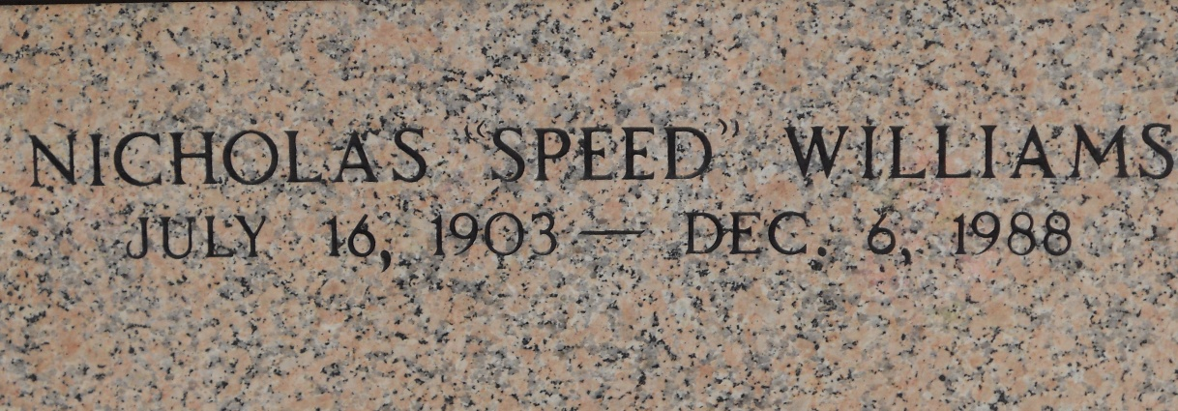
Photo by Team T-Lo

Nicholas (Speed) Williams died Tuesday, 6 Dec 1988, at 8:30 pm at age 85 years. He was a native of Reserve, Louisiana, and a resident of Metairie, Louisiana, for the past 46 years.

Husband of Mildred Schexnayder and brother of O. J., J. P., Richard, and Peter Williams, Rita Simon, Myrtis Guidry, Ethel Mae Trosclair, Joyce Graugnard and the late Roland, Gilbert and Willis Williams, Lucette Duhe and Jonelle Hargis.

Services were Friday, 9 Dec 1988, with interment in St Peter Cemetery, Reserve.
The Times-Picayune, New Orleans, Louisiana
September 13, 1993

