Regina (Hebert) Williams
July 12, 1938 – April 12, 2020

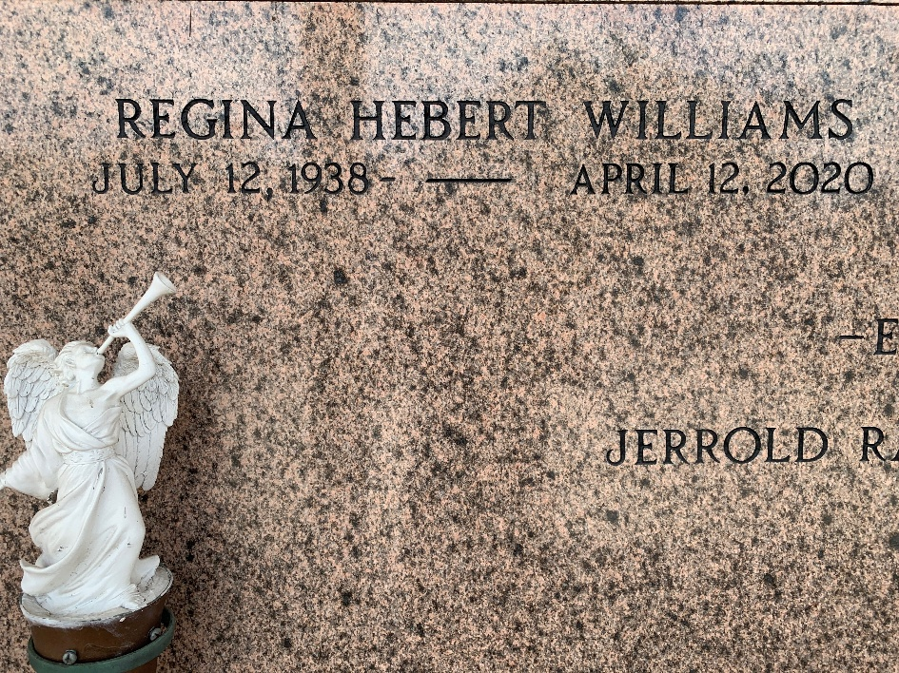
Photo by Team T-Lo

Regina Hebert Williams, a retired librarian with the St. John Parish School Board departed this earthly life on Sunday, April 12, 2020.

Wife of the late Leroy D. Williams, Mother of Jerrold Williams Sr, Grandmother of Deron Martell, Jerrold Jr, Isaiah, and Jeremiah Williams, Sister of Audreye (Isaiah) Henry. Regina is also survived by a host of other relatives and friends.

Private Ceremony and Burial on Saturday, April 18, 2020 at 11:00 am. St. Peter Cemetery, Reserve, LA. Rev. Wilfred Mitchell officiating. Professional Services entrusted to the caring staff Hobson Brown Funeral Home, 134 Daisy St., Garyville, La 70051. 985-535-2516.
The Times-Picayune, New Orleans, Louisiana
April 17-18, 2020

