Walter A. Williams Jr.
July 5, 1949 – November12, 2010

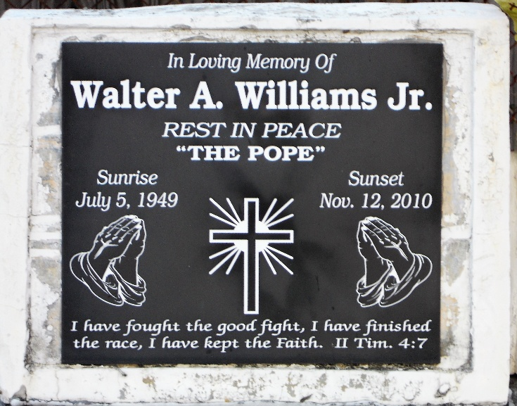
Photo by Team T-Lo

Walter A. Williams, Jr. on Friday, November 12, 2010, at his home in Reserve, LA.
Son of the late Beverly Stewart and Walter Williams, Sr. Husband of Rose Burfict Williams. Father of Shawn (Tony) Jones, Walter III and Danielle Williams and Shanika (Pastor Devin) Mason. Brother of Nathlyn Winfield, Myra (Donnie) Johnson and Hewitt (Nyler) Williams. Also survived by 14 grandchildren, 4 great-grandchildren, 4 godchildren and a host of nieces, nephews, aunts, cousins, other relatives and friends. Age 61 years. A native and resident of Reserve, LA.
Relatives and friends of the family, also pastors, officers and members of New Rescue Mission Baptist Church and all neighboring churches are invited to attend the funeral at New Rescue Mission Baptist Church, 361 E. 14th Street, Reserve, LA on Thursday, November 18, 2010, at 11:00 AM. Pastor Devin Mason, Officiating. Interment at St. Peter Cemetery, Reserve, LA. Visitation at the above-named church from 10:00 AM until service time.
The Times-Picayune, New Orleans, Louisiana
Nov. 17, 2010

