Carmen (Vicknair) Wilson
September 5, 1925 – January 24, 2013

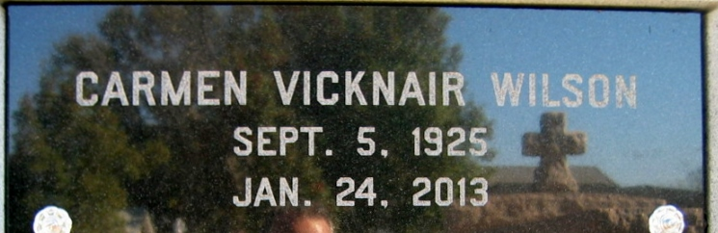
Photo by Bobby

Carmen Vicknair Wilson, born on September 5, 1925, entered peacefully into the arms of Our Heavenly Father on Thursday, January 24, 2013. Age 87.
Beloved wife by first marriage of the late James Wilson and by second marriage of Mark A. Klibert. Beloved mother of Kathy W. Robichaux (Lynn), Barry Wilson (the late Georgette), Keller "Skipper" Wilson (Tal) and Ranney Wilson (Karen) and the late Tanis Wilson. Grandmother of Dawn, Denice, Lynn Jr., Jamie, Jimmy, Steven, Diana, Cassie, Jessica, Ranney Jr., Melissa, Dane, Blake and the late April, Margaret Ann, Christopher and Kristin. Also survived by 23 great-grandchildren and the late Orin Kuhn and 2 great-great-grandchildren.
Daughter of the late John and Lezina Keller Vicknair. Sister of Lois Saucier and the late John Jr., and Marius Vicknair, Carol DeBautte, Lizna Guidry, Rose Madere, and Alice Shultz. A native of Reserve and a resident of Garyville, LA.
She had many hobbies, worked in retail for many years, and a wonderful homemaker and seamstress. Many thanks to Caregivers Lisa White and Joyce Brown. She leaves behind her faithful Bird Gorgeous.
Relatives and friends are invited to attend services. Visitation at Millet-Guidry Funeral Home, 2806 W. Airline Hwy., LaPlace, LA on Sunday, January 27, 2013 from 5:00pm to 9:00pm and on Monday from 10:00am to 11:30am, followed by Mass at St. Joan of Arc Catholic Church, LaPlace, LA at 12:00 noon. Burial in St. Peter Cemetery, Reserve, LA.
The Times-Picayune, New Orleans, Louisiana
January 25-27, 2013

