James Theodore Wilson Sr.
February 9, 1916 – August 2, 2011

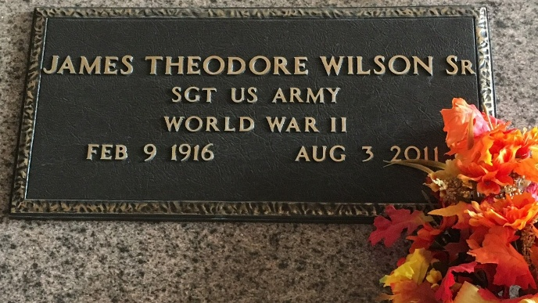
Photo by Team T-Lo

James T. Wilson, Sr. "Rock" was called by angels who came and whispered to him it was time to come home and rest on Tuesday, August 2, 2011 at the Southeast War Veterans Home, Reserve, LA.
Son of the late John and Mathilda W. Wilson. Beloved husband of the late Bessie K. Wilson. Loving father of James T. Wilson, Jr., Yolanda W. Joseph and Kitty W. Goudia all of LaPlace, LA. Brother of Lenda W. Dunn of LaPlace, LA, Beatrice Benn, Margaret Lawerence, Catherine Moton, and Jacqueline Jackson all of Los Angeles, California, the late Cecilia W. Hall, Harold S., Clarence J., and M-Sgt. Rubin E. Wilson. Grandfather of Romell, Nioka, Heather, Brianna, Kadada, Ambre and James T. Wilson, III, Kyrian and H. Eric Joseph, II, Glenn Goudia, Jr. and Annderlyn G. Martin. Also survived by a host of great grandchildren, nieces, nephews, cousins, other relatives and friends. Age 95 years. A native and resident of LaPlace, LA and a World War II Veteran.
Relatives and friends of the family, also priest and parishioners of Our Lady of Grace Catholic Church, pastors, officers and members of First Community Antioch Baptist Church and all neighboring churches and employees of St John the Baptist Parish School System, Marathon Oil Company, Monsanto, Noranda Aluminum of Gramercy, LA, and Regions Bank are invited to attend the Mass of Christian Burial at Our Lady of Grace Catholic Church, 772 Highway 44, Reserve, LA, on Wednesday, August 10, 2011 at 11:00 AM. Father Joseph Rodney, Celebrant. Interment: St Peter Cemetery, Reserve, LA. Visitation at the above named church from 9:00 AM until Mass time.

Unknown source

