Rubin E. Wilson
October 26, 1928 – June 26, 2009

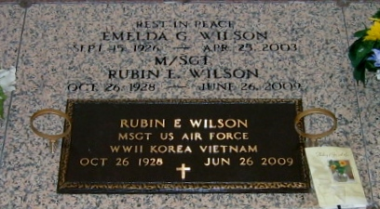
Photo by Bobby

Rubin E. Wilson, a retired M/Sgt. of the United States Air Force, departed this life on Fri., June 26, 2009 at East Jefferson Hospital. Age 80 years.
Son of the late John and Mathilda Wilson. Husband of the late Emelda G. Wilson. Father of Lynette Wilson, Irma Thomas and Gil Wilson. Grandfather of Caujina Thomas Lazard and the late Halario Thomas.
Brother of James Wilson, Beatrice Ben, Lenda Dunn, Margaret Lawrence, Jacqueline Jackson, Catherine Moton and the late Cecile Hall, Harald and Clarence Wilson.
A native and resident of LaPlace, LA.
The Times-Picayune, New Orleans, Louisiana
July 1, 2009

