Frances (Mayhew) Winfield
November 30, 1917 – January 19, 2007

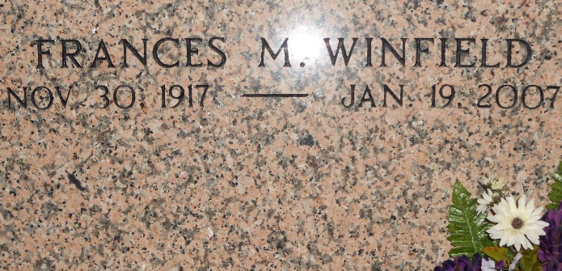
Photo by Team T-Lo

Frances Mayhew Winfield, a retired nurse, on Friday, January 19, 2007 at Canon Hospice in Metairie, LA.
Wife of the late Wilbert Winfield. Daughter of the late Martin Mayhew and Mary Brown Mayhew. Godmother of Christina G. Davis of Reserve, Louisiana. Cousin of Lillie Mae Green, Conchetta G. Mason and Sandra G. Snyder of Dallas, Texas, Adrian D. Walker and Michael J. Green, Sr. of Reserve, LA and Benjamin T. Green, Jr. of Tacoma, WA. Also survived by seven great-nieces and -nephews in Philadelphia, PA; other cousins, relatives and friends.
She was preceded in death by a sister, two brothers and a nieces, Francine Butler. Age 89. Born in Philadelphia, PA, moved to New York City at age 12 and retired to Reserve, LA at age 67.
Relatives and friends of the family; pastors, officers and members of Greater New Plymouth Rock B.C. and all neighboring churches; also members of Reserve Chapter AARP 5321 and Riverbend Lanes Senior Bowling Leagues are invited to attend Funeral Services on Saturday, January 27, 2007 at 11:00 a.m. at the above named Church located at 110 Northwest 13th Street, Reserve, LA. Pastor David B. Carter, officiating. Visitation 9:00 a.m. until 10:45 a.m. NO WAKE. Interment St. Peter Mausoleum, West 7th Street, Reserve, LA.
Arrangements by THE BALONEY FUNERAL HOME, L.L.C. 399 Earl Baloney Dr., Garyville, LA 70051 Information: (985) 535-2540
Times Picayune, New Orleans, Louisiana
January 26, 2007

