Marie (Schuster) Wisniowiecki
October 3, 1927 – May 17, 2023

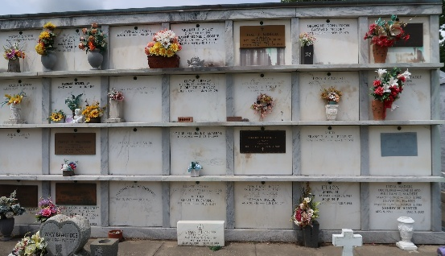

Maria, loving mother and grandmother, passed away on May 17, 2023 at the age of 95.
Maria Schuster Wisniowiecki was born on October 3, 1927 in Romania and lived in Austria during her teenage years. She came to America on a work VISA in 1952. From that time she resided in Lions where she met her husband the late Antoni Wisniowiecki and since has been a resident of Reserve, LA for the past 47 years. She became a citizen of the USA in 1981.
Maria is preceded in death by her husband of 23 years Antoni as well as her siblings John Schuster, Katrina Krashaar and Freda Kopp.
She is survived by her children Reinhard Schuster (Lynn), John Wisniowiecki (Alice), Ursula Rouillier (late Charles, Jr.), Erika Montz (Randy), Helga Blank and Diane Ramagos (Marshall), grandchildren Lisa, Michael, Robert, Richard, Ryan, Gwen, Mathew, Christopher, Kaini, Kalie, Chrissie, Kevin, Nicholas, Francis and her 16 great-great grandchildren and 1 great-great-great grandchild. She loved and cherished her family. She will be missed by everyone.
Being outdoors in her flower garden and growing her own vegetables was a favorite pass time. Along with her sewing, crochet and knitting.
Maria’s family would like to thank Ascension Oaks Home and Hospice of Baton Rouge for the love and kindness given to her and her family.
Relatives and friends are invited to attend a visitation and Funeral Mass on Wednesday, May 24, 2023 at St. Peter’s Catholic Church,1550 Hwy 44, Reserve, LA. Visitation will begin at church at 9:30 AM followed by a Funeral Mass at 11:00 AM. Interment to follow in St. Peter Catholic Cemetery in Reserve, LA.

Millet-Guidry Funeral Home, LaPlace, Louisiana
May 18, 2023

