Henry Peter Wolfe Sr.
Abt. 1917 – December 13, 2005

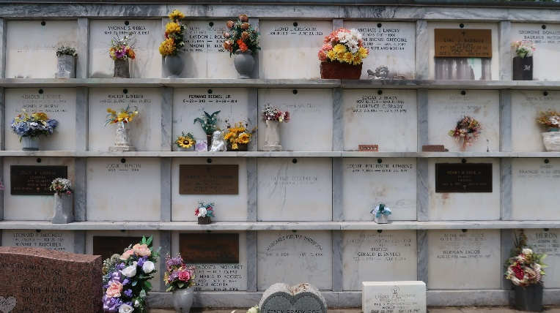

Henry Peter Wolfe, Sr. On Tuesday, December 13, 2005 At Cannon Hospice, Metairie, La.
Son Of The Late Eugene And Martha Wolfe Lewis Of Montz, La. Beloved Husband Of The Laote Lithia Etienne Wolfe. Father Of Gwendolyn W. Hall Of Laplace, La, Richard Dlae Wolfe Of Reserve, La And Rev. Henry Wolfe, Jr. Of Hahnville, La. Brother Of Rita Williams Of New Sarpy, La, Alvin Lewis Of Maryland, The Late Joseph Lewis, William Wolfe, Mildred Thomas, Marion Wallace, Albertine Tyree, Lydia Winchester And Dorothy Thomas. Also Survived By 18 Grandchildren, 33 Great Grandchildren, 8 Great Great Grandchildren And A Host Of Nieces, Nephews, Other Relatives And Friends.
Age 88 Years. A Veteran Of Worlds War II And A Mechanic In The United States Army. A Native And Resident Of Laplace, La.
Relatives And Friends Of The Family, Also Priest And Parishioners Of Our Lady Of Grace Catholic Church, Pastors, Officers And Members Of Canaan Baptist Church Of Killona, La And All Neighboring Churches, Members Of The Knights Of Peter Claver, St. Catherine Council #73, St. John The Baptist Parish School System, St. John The Baptist And St. Charles Parishes Government Employees Are Invited To Attend The Mass Of Christian Burial At Our Lady Of Grace Catholic Church, 772 Highway 44 (River Road), Reserve, La On Saturday, December 17, 2005 At 11:00 Am. Father Joseph Rodney, Celebrant. Interment St. Peter Cemetery, Reserve, La. Visitation At The Above Named Church From 9:00 Am Until Mass Time. Serviced By Robottom
Times Picayune, New Orleans, Louisiana
December 16, 2005

