Shane Michael Zeringue
May 23, 1976 – January 4, 2019

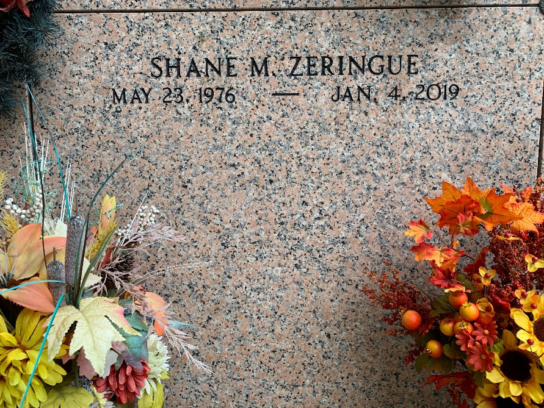
Photo by Team T-Lo

Shane Michael Zeringue, age 42, passed away on January 4, 2019. He was a native of LaPlace, LA and a resident of Hammond, LA.
He is survived by his daughter, Madisyn Zeringue (daughter of Charlotte Taylor Zeringue); his parents, Ray Zeringue, Jr. and Donna Torres Zeringue; siblings, Brandy Zeringue Murden (Michael), Heather Zeringue, Rhea Zeringue Cressionnie (Kyle), Sean Zeringue (Danesha), Tommy Zeringue, and Lily Zeringue; and nieces and nephews, Grace Vicknair, Bryce Murden, Lucy Cressionnie, and Colt Cressionnie.
He was preceded in death by his grandparents, Donald Torres, Ray Zeringue, Sr., and Barbara Zeringue; and cousin, Donald Torres, Jr.
A memorial visitation in his honor will be held on Friday, January 11, 2019 at Rose Lynn Funeral Home in Lutcher, LA from 11 a.m. to 12 p.m. Prayer service to follow at 12 p.m. Private burial to take place at St. Peter’s Cemetery in Reserve, LA.

Millet-Guidry Funeral Home, LaPlace, Louisiana

