Jessie Howard

Abt. 1958 – March 15, 2018

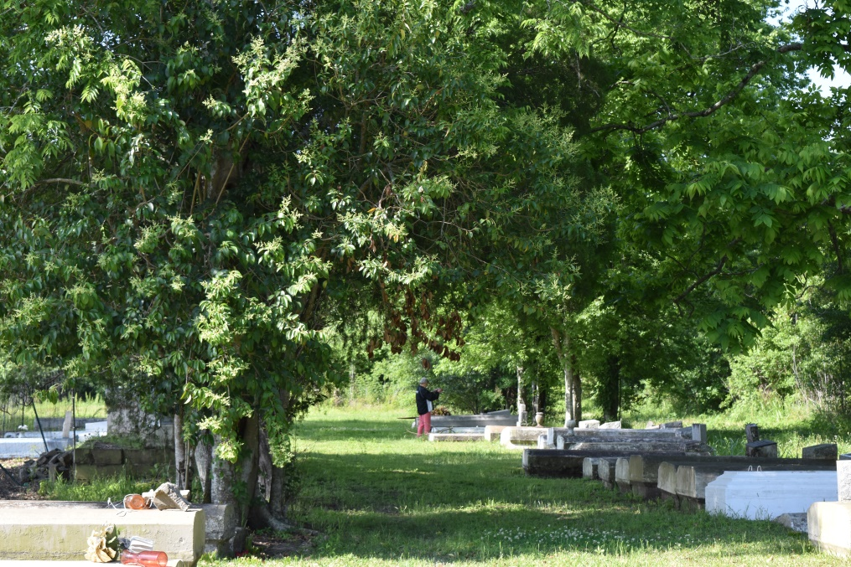

Jessie Howard at the age of 60 yrs. departed this earthly life on Thursday March 15, 2018 at Our Lady of the Lake Hospital of Baton Rouge, La. Loving brother of Rose Howard of Paulina, La., Laura Howard, Iris Howard, Brender Howard and Phillip Howard (Valerie) of Edgard, La., Mary Howard Stewart and Glenn Howard of Vacherie, La. Also survived by a host of aunts, uncles, nieces, nephews, other relatives and friends. Jessie was preceded in death by his parents Venessoa Lewis Howard and John Howard; Siblings: Linda Dupard, Gloria, Irene, Oneil and Frank Howard. Pastors, Officers and Members of The Morning Star Baptist Church of Wallace, La. and all neighboring churches are invited to attend the home going celebration on Saturday March 24, 2018 at 11:00 am at The Morning Star Baptist Church 5355 River Road High 18 Wallace, La. Pastor Frank Johnson officiating. Interment in Willow Grove Cemetery of Wallace, La. Visitation will be at the above name church from 9:00 am until service time. Bardell's Mortuary of Mt. Airy, La. in charge. Information: 985-535-6837.

Published in TheNewOrleansAdvocate.com from Mar. 22 to Mar. 24, 2018