Alvin Jones

June 21, 1929 – December 4, 2008

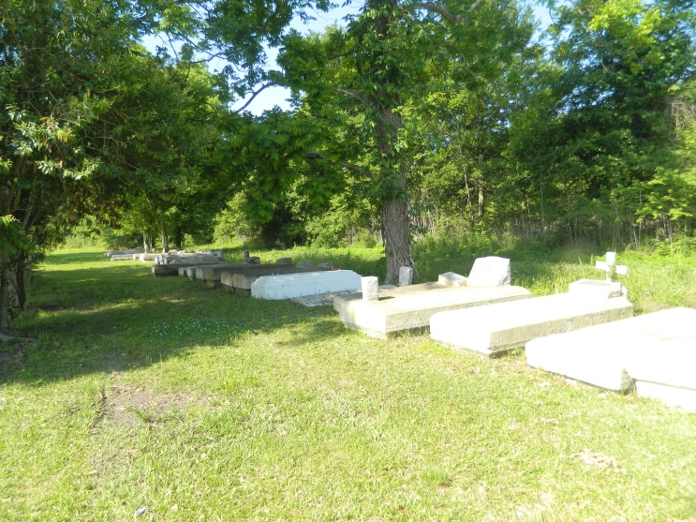

Alvin Jones of New Orleans at Touro Hospital on Thursday, December 4, 2008. Son of the late Ernest Jones and Gertrude Duhe Rogers Jones. Husband of the late Priscilla Mae Batiste Jones. Father of Denise Jones, Alvin Jr., Frederick Jones, Dennis Jones, the late Jeanette J. Gaylor and Jerome Jones. Brother of Phillip Rogers, Shirley Ross, the late Willie Rogers and nine sisters. [\*blended family\*] Grandfather of Shelita Gaylor, Melanie Turner, Lateria Jones, Nia Jones, Frederick Ross, Sean Gaylor, Jerome Gaylor and the late Kevin McKenzie. Also survived by a host of great-grandchildren, nieces, nephews, cousins and friends. Devoted cousin of Dorothy Johnson. Devoted friend of Chester and Jean Lewis. A native of Wallace and a resident of New Orleans. Age 79 years.

Visitation and services were held on Friday, December 12 at the James Chapel B.C. in New Orleans. Interment in Willow Grove Cemetery in Wallace.

L'Observateur, LaPlace, Louisiana

Friday, December 12, 2008