Audrey Mae (Marshall) Bethancourt

January 6, 1937 – August 27, 2014

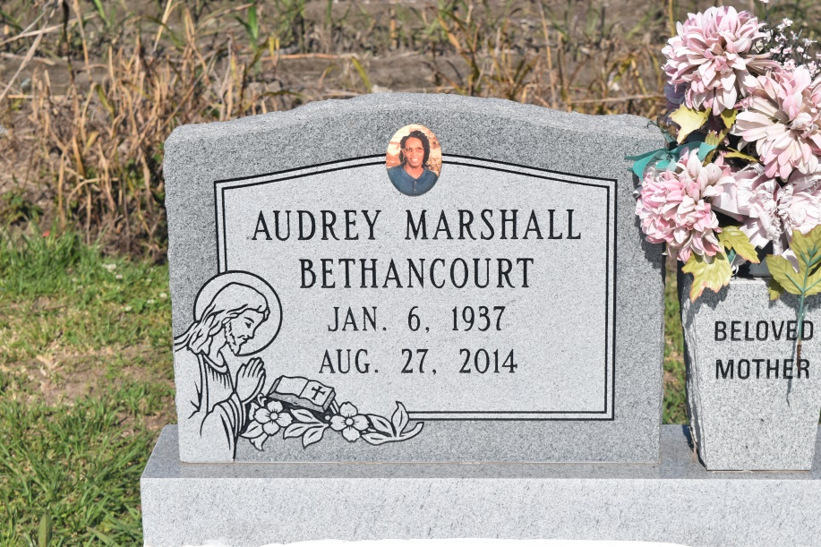

AUDREY MAE MARSHALL BETHANCOURT entered into her eternal rest with her Heavenly Father on Wednesday, August 27, 2014 at St. James Hospital, Lutcher, LA Daughter of the late Rev. Frank and Ethel Marshall, Sr. Beloved wife of the late Norman Bethancourt, Sr. Mother of Shirley, Joseph, and Donald Davis, Yolanda (Bobby) Arceneaux Isaac, Brian (Shannica) and Telly (NyKosha) Bethancourt Step mother of Cynteia Jessie, Guindella Joseph, Avis Pickens and Norman Bethancourt, Jr. Sister of Frank Marshall, Jr., Lorraine Grant, Joyce Pierre, Barbara, Gilbert, and Ervin Marshall, JoAnn Naquin, Lamonte Marshall, the late Doris Darby and Leroy Marshall Also survived by 16 grandchildren, 5 great grandchildren, a devoted friend Belinda Valentine and a host of brothers and sisters in law, nieces, nephews, cousins, God-children, other family and friends. Age 77 years. She was a devoted church member of Greater Woodville Baptist Church. Audrey was a retired cook from the St. John the Baptist Parish School System.  
  
Relatives and friends of the family, also pastors, officers and members of Greater Woodville Baptist Church and all neighboring churches and employees of St. John the Baptist and St. Charles Parish School Boards, St. Charles Parish Hospital, Turner Industries, AEP Riverboat Operations, Vacherie and St. James Dialysis Center are invited to attend the Home Going Service at Greater Woodville Baptist Church, Wallace, LA on Saturday, September 6, 2014 at 11:00 AM Rev. Marc A. Nelson, Sr., Pastor, Officiating Interment Woodville Cemetery, Vacherie, LA Visitation at the above named church from 9:00 AM until service time.  
  
SERVCED BY ROBOTTOM

Times-Picayune, The (New Orleans, LA) - Friday, September 5, 2014

**Contributed by Jane Edson**