Felmon Bethancourt

October 12, 1936 – December 29, 2017

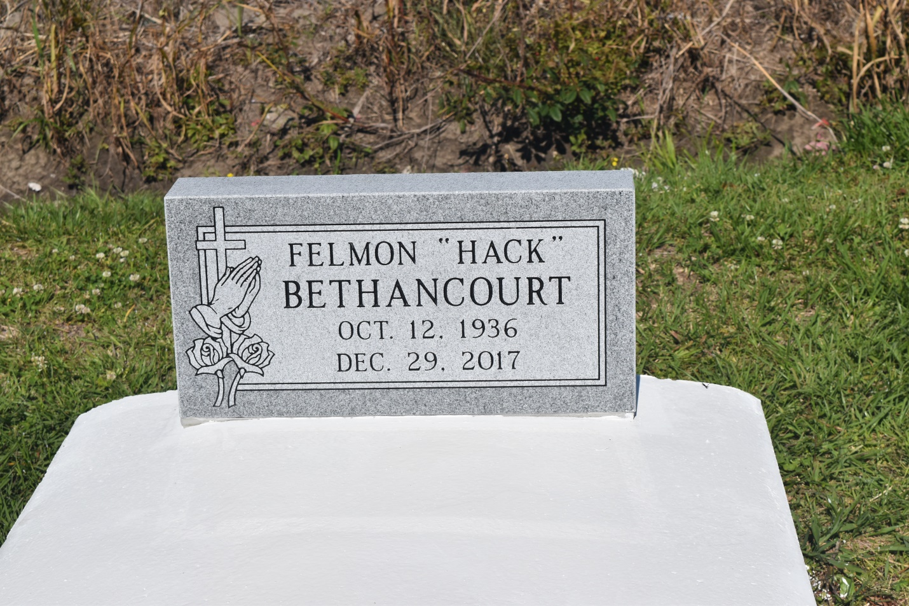

Felmon “Hack” Bethancourt of Edgard, Louisiana, age 81, transitioned to his heavenly home on Friday December 29, 2017. Son of Floristone Bethancourt and Evelyn Hall Bethancourt of Wallace, LA. Husband of 56 years to Gloria Jean Rainey Bethancourt. Father of Delbert, Shawna, Andrea, and Deidre Bethancourt of Edgard, and Chandra (Darryl) Landry of Marrero, LA, and the late Christopher Bethancourt. He was the grandfather of Cameron, Odyssey, Aaron, and Da’Shanta Bethancourt; Blaine and Keirston Gautier; Darryl Landry, Jr.; Kenisha Kendrick; and Amber Favorite; and the great-grandfather of eight. Brother of the late Daniel, Sr, Norman, Sr., Therold and Dennis Bethancourt; Estelle B. Irving, and Juanita B. Williams. Devoted friend of Mallory Clark, Ellis Hall, Anthony and Mitchell Jackson, and Elmo and Merlin Alexis. Also survived by a host of sisters-in-law, brothers-in-law, nieces, nephews, other relatives and friends.

Relatives and friends, pastors, officers, and members of New Jerusalem Baptist Church, Edgard, LA; Greater St. Stephens Full Gospel Baptist Church, New Orleans, LA; Greater Woodville Baptist Church, Wallace, LA; and all neighboring churches are invited to attend the homegoing services at New Jerusalem Baptist Church, 152 East 6th St. Edgard, LA., on Saturday, January 6, 2018 at 11:00 a.m., Rev. K. Maurice Tillman, Pastor; Rev. Barry Guillory-officiating. Viewing from 9:00am until time of service. Interment at Woodville Cemetery, Wallace, LA. Treasures of Life Funeral Services, 315 E. Airline Hwy, Gramercy, LA 70052, have been entrusted with his final care.  
“When someone you love becomes a memory, that memory becomes a TREASURE!”

**Downloaded from obittree.com on 4/28/2018**