O'Lando Colementa Carter

1974 – May 3, 2017

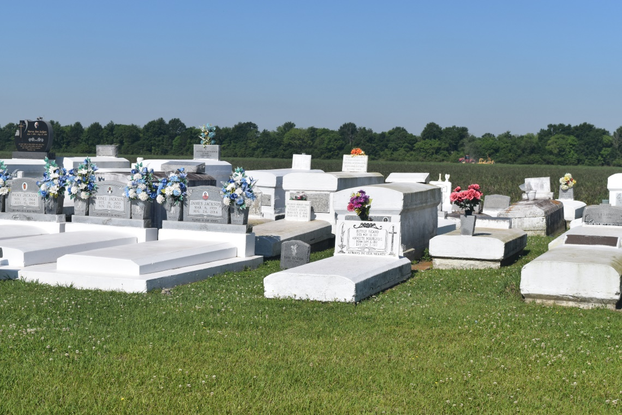

O' Lando Colementa Carter, departed this life on May 3, 2017 at 1:11pm. The first child to Marie (George) Green Jr., and the late Isaiah Carter. He accepted Christ and was baptized at an early age by the late Rev. Wilkerson N. Grant. He was a graduate of West St. John High School Class of 1993.

O’Lando leaves to cherish his memories children Kalon & Makaila Carter; siblings Louvanzell Jackson, Darryl Carter, Michelle Carter, and Robert (Tiffany) Carter; devoted friend Koffee Arrington and a host of uncles, aunts, nieces, nephews, cousins, and friends. He is preceded in death by his father Isaiah Carter, Jr., grandfather Bienville Jackson, Sr., grandmother, Annie Mae B. Jackson, aunt Ethel M. Young; three uncles Henry Clay, Louis Carter, Harris Carter and godmother Brenda Jasmin.

A celebration of life will be held on Saturday May 13, 2017 at 11:00am from New Zion Christian Center 216 West Main St. Gramercy, La. -Pastor Emile Dean Mitchell officiating. Interment Woodville Cemetery, Wallace, La. Visitation at the church after 9:00am on Saturday. Final care entrusted to Treasures of Life Funeral Services 315 E. Airline Hwy. Gramercy, La.

[www.treasurefunerals.com](http://www.treasurefunerals.com) (accessed 10/18/2018)