Hersey Farlough
April 18, 1945 – June 23, 2015

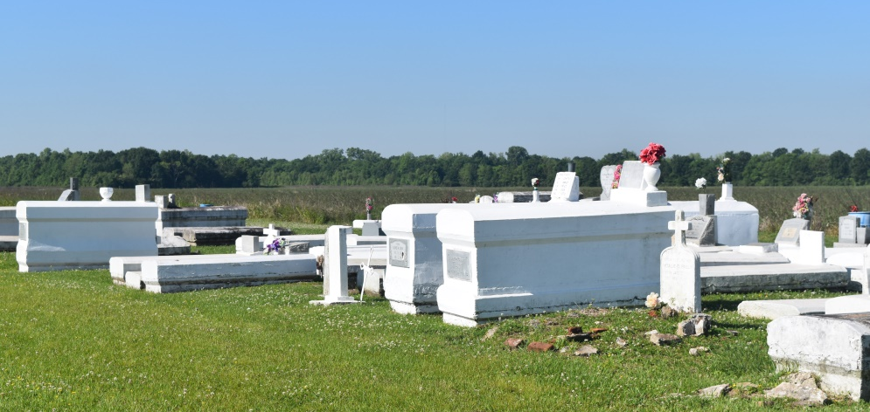

Hersey Farlough, 70, a native of Mt. Airy, La., and a resident of Lutcher, La., passed away peacefully at Chateau St. James in Lutcher, La., and entered Heaven's gate on June 23, 2015. Hersey was born on April 18, 1945 to the late Earl and Sylvia Farlough. Hersey leaves to cherish his memories 2 daughters Lisa James of Gonzales, La., and Monique (Donald) Patin of Baton Rouge, La., 5 grandchildren Rondeanda Mills, Joshanique Patin, Trabar, Trevin, and Troydell Williams, 7 great-grandchildren, 1 brother Hilton (Faith) Farlough of Reserve, La., 3 sisters Myrtle Victor of Reserve, La., Greta Farlough of Texas and Phillis Farlough of Gonzales, La., 1 sister in law Barbara Farlough, 2 godchildren Errol Victor, Felicia Farlough Cox, and a host of nieces and nephews.

Chateau St. James, neighboring churches, family and friends are welcome to join us in the home going celebration on July 11, 2015 at 11:00 am at St. John Missionary B.C., 287 Daffodil St., Mt. Airy, La., officiated by Pastor Gary Bolden Sr. followed by an Interment at Woodville Cemetery in Wallace, La., Bardell's Mortuary of Mt. Airy, La., in charge. Information: 985-535-6837.

Downloaded from legacy.com on 4/28/2018

