Wilbert Gordon, Sr.

June 28, 1921 – January 16, 2007

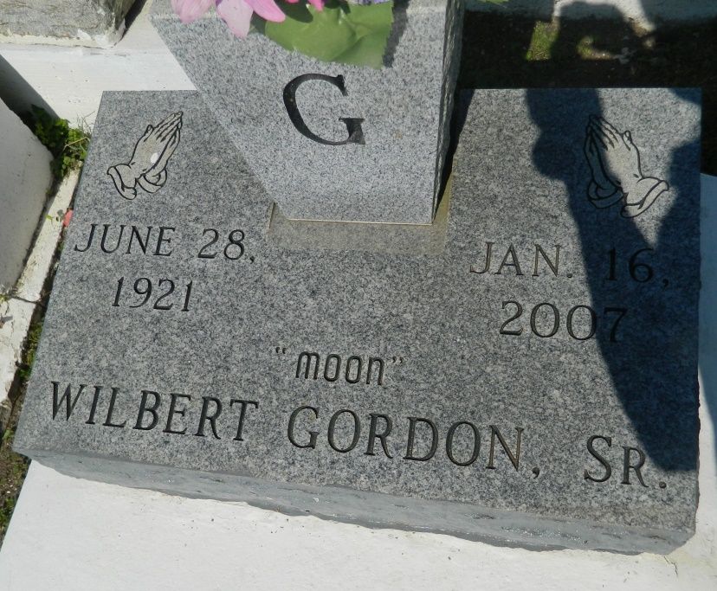

Wilbert (Moon) Gordon, Sr. a retired shipyard worker of Wallace, LA at James Hospital, Lutcher, LA on Tuesday, January 16, 2007. Son of the late Isaac and Almonia Gordon. Beloved husband of the late Rosemary B. Gordon. Father of Karen Pierre, Patrick Gordon, Willa Gordon, Verna (Milton) Clofer, Sheryl Johnson of Wallace, LA, Dale Gordon and Lucille (Conrad) Sorapuru of LaPlace, LA, and the late Landry, Edmond, Willa Mae, Joyce Marie, Rosemary, Eric, Cedric Sr., Wilbert Gordon Jr., and Mildred G. Brown. He lovingly reared Michael and Alfred Adams, Joseph Porter, James Adam and Henry Clay. Brother of Loverta Clofer of Marrero, LA, and the late Wilherine Jackson, Rebecca Marshall, Venus, Samuel Sr., Easter, Iasiah, Isaac and Isreal Gordon. Robert and Edward Stewart. Also survived by (1) daughter-in-law, a host of sisters and brothers-in-law, (31) grandchildren (35 great grandchildren, nieces, nephews, other relatives and friends and the Greater Woodville Baptist Church Family, A native and resident of Wallace, LA. Age 85 years.  
  
Relatives and friends of the family, also pastor, officers and members of Greater Woodville Baptist Church and neighboring churches, employees of St. John School Board, Northrop Grumman, Comprehensive Security, Delaware Co. and Prudential Gardner Realtors are invited to attend the funeral services on Saturday, January 20, 2007 at 12:00 p.m. (Noon) from the Greater Woodville Baptist Church, Wallace, LA. Rev. Marc Nelson, Sr. officiating. Interment church cemetery. Visitation at the church after 8:00 a.m.  
  
The Baloney Funeral Home L.L.C., 399 Earl Baloney Drive, Garyville, LA 70051,   
(985) 535-2540 in charge of arrangements.

**Times-Picayune, The (New Orleans, LA) - Friday, January 19, 2007**

**Contributed by Jane Edson**