Alfred Elmore Grant Sr.

May 15, 1927 – January 12, 2007

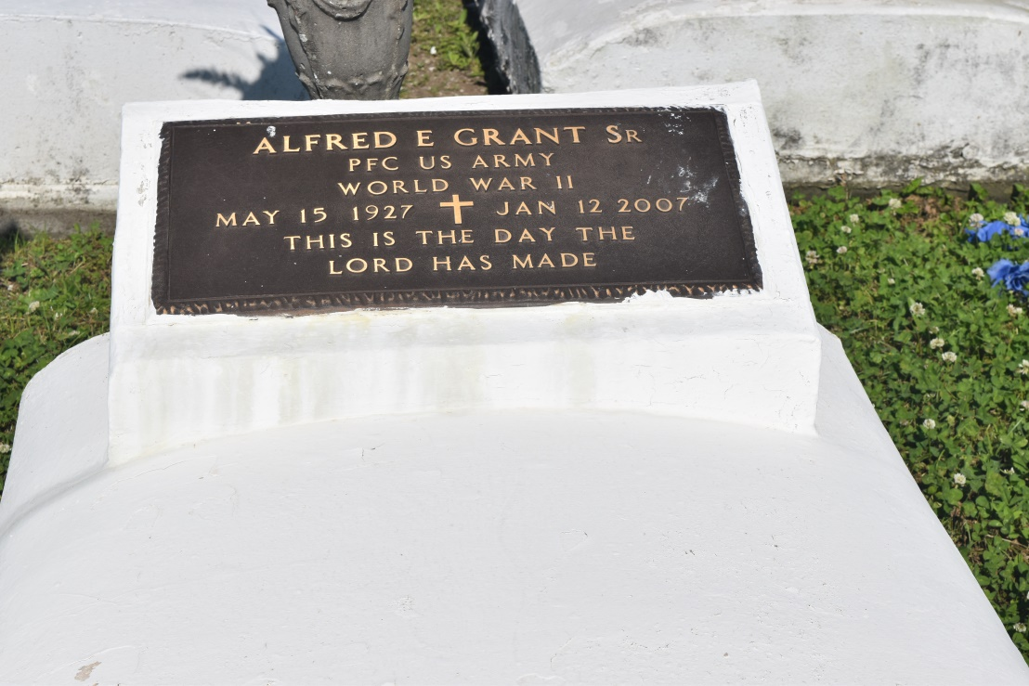

Alfred Elmore Grant, Sr., beloved husband, father and grandfather, passed away peacefully at his home on Friday, January 13, 2007 in Wallace, Louisiana. Alfred was born on May 15, 1927 in Wallace, Louisiana to the late Louella Holly and Rev. Wilkerson Grant.  
  
He was united in holy matrimony to Carolyn Savoie Grant in 1950. He was the devoted father of Charlotte Grant of Jefferson, LA; Alfred Grant, Jr. (Elaine) of St. James, LA., Ricky Grant (Hilda) of Baton Rouge, LA and Frank Harris (Mary) of Hammond, LA. Grandfather of eleven grandchildren and 8 great grandchildren. He has three sisters Ethel Anderson, Augustine and Ruby Grant of Lutcher, LA.  
  
Alfred was a dedicated and devoted member of Greater Woodville Baptist Church. He retired from Colonial Sugar after 45 years of service in Gramercy, LA.  
  
Relatives and friends of the family; employees of Colonial Sugar and neighboring Churches are invited to attend the funeral services at the Greater Woodville Baptist Church, 132 West 9th Street, Wallace, LA. Rev. Marc A. Nelson, Pastor, officiating, on Tuesday, January 16, 2007 at 10:00 a.m. Visitation 9:00 a.m. until service time. Interment Woodville Memorial Cemetery.  
  
Arrangements entrusted to The Baloney Funeral Home, LLC, Garyville, Louisiana.

**Times-Picayune, The (New Orleans, LA) - Monday, January 15, 2007**

**Contributed by Jane Edson**