James Jackson

March 8, 1939 – August 24, 2014

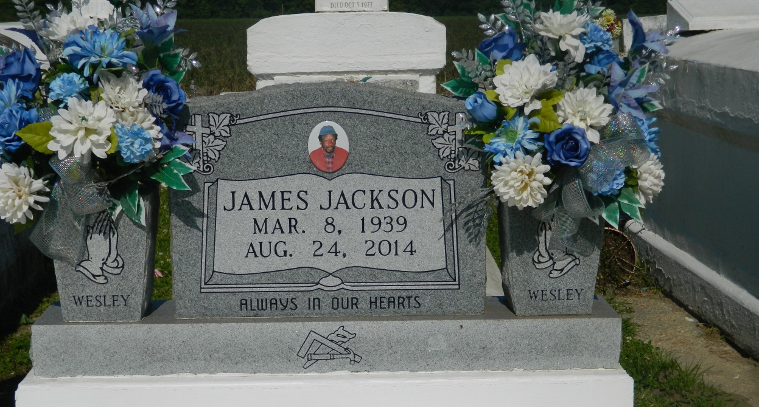

James "Wesley" Jackson born March 8, 1938 passed away on Sunday August 24, 2014. He was the son of the late Lester and Wilberine Jackson. Beloved husband of Dorothy Jackson. Father of Donna (Jeffery) Scott and the late Lionel and Ricky Jackson. Also, survived by his grandchildren Tonyaneka Jackson, Olajuwon Hall, Desmond Brown Daygra and Devre Poche. Seven great grandchildren, one sister Clara Edwards, four brothers Isaac, Chatman, Clarence and Terrell Jackson, five brother in laws, nine sister in laws, a host of nieces, nephews, cousins other relatives and friends. Age 75 years.  
  
Relatives and friends of the family also pastor, officer and members of the Greater Woodville Baptist Church, Philadelphia B.C. and all neighboring churches, the staff of St. James Parish Hospital, St. Joseph Hospice are invited to attend the funeral services at the Greater Woodville B.C. in Wallace, La on Thursday August 28, 2014 at 11:00 a.m. Rev. Marc A. Nelson Sr., Pastor officiating. Interment Woodville Cemetery Wallace, La. Visitation at the above name church from 9:00 a.m. until service time.  
  
Service by Bardell's Mortuary of Mt. Airy, La. Information: 985-535-6837

**Times-Picayune, The (New Orleans, LA) - Wednesday, August 27, 2014**

**Contributed by Jane Edson**