Lionel Jackson

October 18, 1959 – November 24, 2010

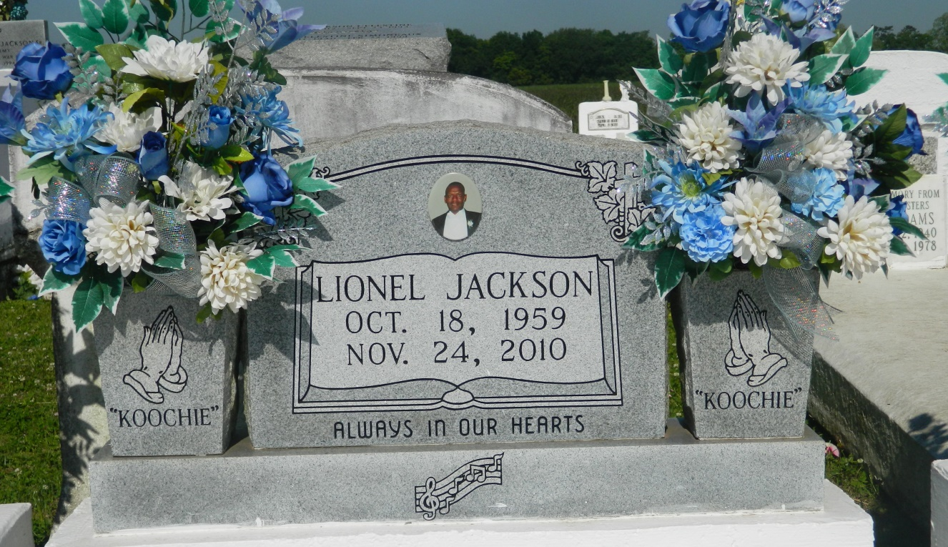

Lionel "Koochie" Jackson, age 51, entered into eternal rest on Wednesday, November 24, 2010 at University Hospital in New Orleans, La. Beloved son of James and Dorothy Jackson. Father of Tonyaneka Jackson, Devre & Daygra Poche, and Desmond Brown. Brother of Donna (Jeffery) Scott and the late Ricky Jackson. 3 grandchildren known to them as "Poppe", Maiden Allen, Allyah and Allon Williams. 1 nephew Olajuwon Hall. Also survived by a host of aunts, uncles, cousins, other relatives and friends.  
  
Relatives and friends of the family, also pastor, officers and members of First B.C. of Vacherie, First Community Antioch B.C. of Gramercy, and Second Salvation B.C. of Bridge City, La. and all neighboring churches, employees of St. John Parish School System and the class of 1978 West St. John are invited to attend the funeral service at Greater Woodville Baptist Church on Tuesday, November 30, 2010 at 11:00 a.m. Pastor Marc A. Nelson Sr., officiating. Visitation begins at 9:00 a.m. until time of service. Interment at church cemetery. The Baloney Funeral Home LLC in charge of arrangements. Guests may sign the register at [www.baloneyfuneralhome.com](http://www.baloneyfuneralhome.com).

**Times-Picayune, The (New Orleans, LA) - Monday, November 29, 2010**

**Contributed by Jane Edson**