Wanda (Brooks) Alexander

March 13, 1957 – September 24, 2010

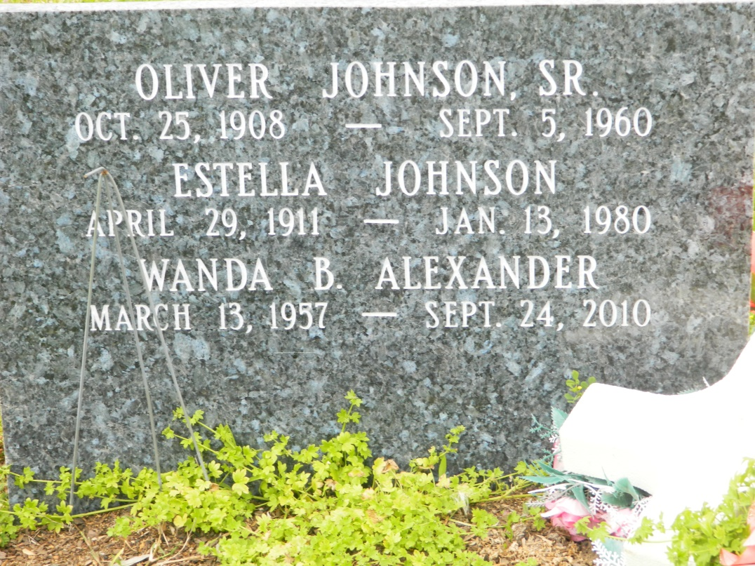

Wanda Brooks Alexander on Friday, September 24, 2010. Daughter of Audrey Johnson and the late Ory Brooks, Sr. Sister of Morris, Jacqueline, Cheryl, Mavis, Candy, Priscilla, and the late Ory Brooks Jr., Gary, Wilbert and Ella. Also survived by a host of other relatives and friends.  
  
Relatives and friends of the family, members of Franklin Ave. Baptist Church, Greater St. Peter Baptist Church, May Flower Society and Class of 1975-2nd Ward High School, Edgar, La. are invited to attend the Funeral Services on Saturday, October 2, 2010 at Franklin Avenue Baptist Church, 2515 Franklin Ave., NOLA 70117 at 10:00 a.m. Visitation from 9:00 a.m. to 10:00 a.m. Rev. Fred Luter officiating. Interment: Young Cemetery Edgar, La.  
  
Services Entrusted to: LOUISIANA UNDERTAKING CO., 1449 N. Claiborne Ave., NOLA 70116, Information: (504) 945-2145; Renard A. Boissiere, Director; Robert P. Francois, Owner

**Times-Picayune, The (New Orleans, LA) - Friday, October 1, 2010**

**Contributed by Jane Edson**