Genorta Augusta

January 4, 1939 – February 8, 2014

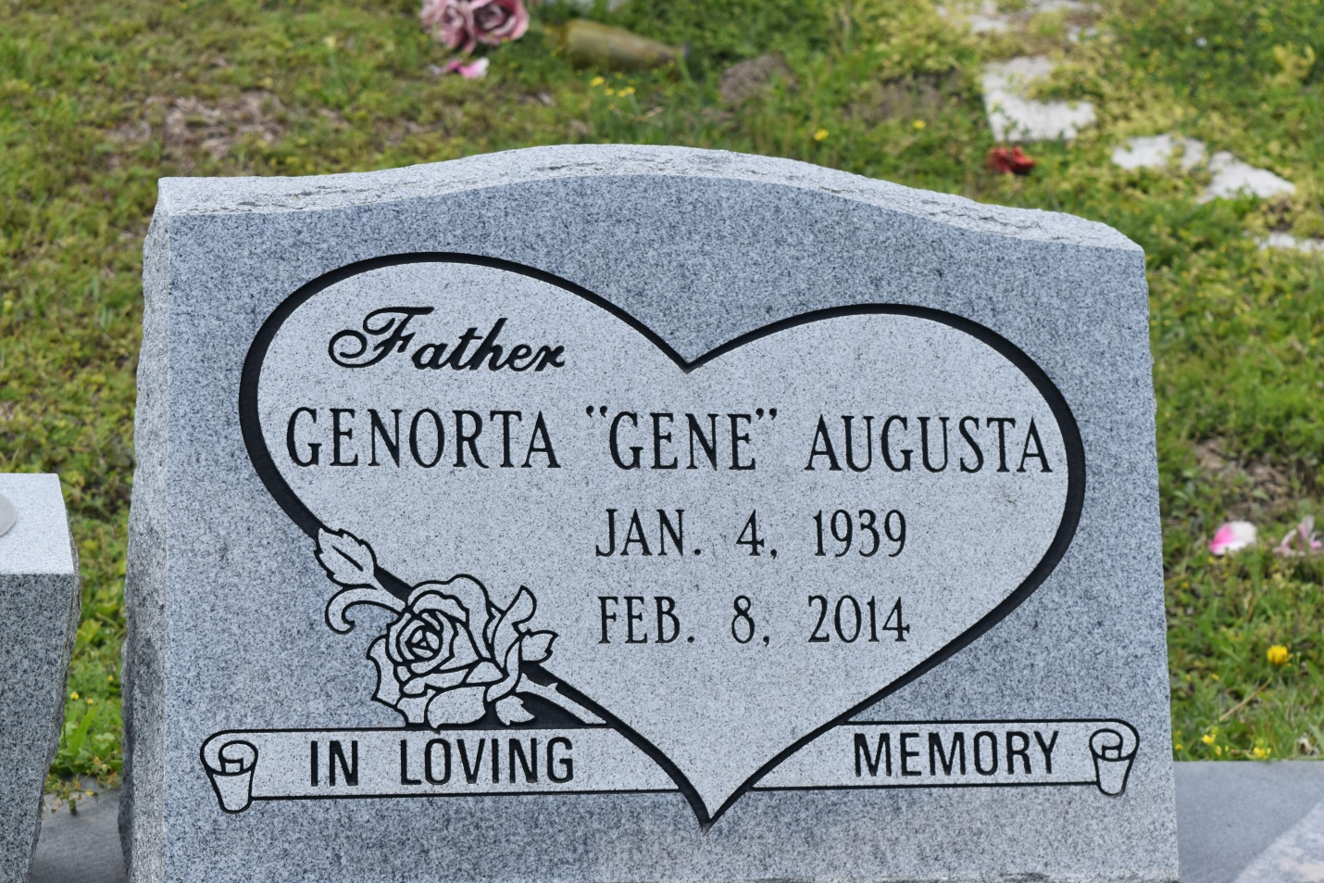

Genorta "Gene" Augusta at the age of 75 yrs. departed this earthly life and entered into eternal rest on Saturday, February 8, 2014, at Ochsner Hospital of Metairie, LA. Beloved husband of Victoria C. Augusta of Edgard, LA. Loving father of Victoria Hanson (Barry), Paulette Barnes (David), Patricia Melendez (Kevin), Regina Augusta, and Violet Bornes (Brian). Also survived by 3 brothers, 5 sisters, 13 grandchildren, 9 great-grandchildren, and a host of nieces, nephews, other relatives, and friends. A native and resident of Edgard, LA.  
  
Relatives and friends of the family, also pastors, officers of New Jerusalem Baptist Church, My Heart to Yours Church, St. Peter Baptist Church, Employees of Hampton Inn of LaPlace, LA, Burmada of Luling, Wal-Mart of Boutte, LA, Ormond Nursing Care Center of Destrehan and all neighboring churches are invited to attend the Homegoing Services on Saturday, February 15, 2014, at 11:00 a.m. at New Jerusalem Baptist Church, 152 E. 6th St., Edgard, LA. Rev. K. Maurice Tillman officiating. Interment in Young Cemetery of Edgard, LA. Visitation will be from 9:00 a.m. until service time at the above church.  
  
Bardell's Mortuary of Mt. Airy, LA in charge. Information: 985-535-6837

**Times-Picayune, The (New Orleans, LA) - Friday, February 14, 2014**

**Contributed by Jane Edson**