Victoria C. Augusta

July 18, 1940 – October 24, 2012

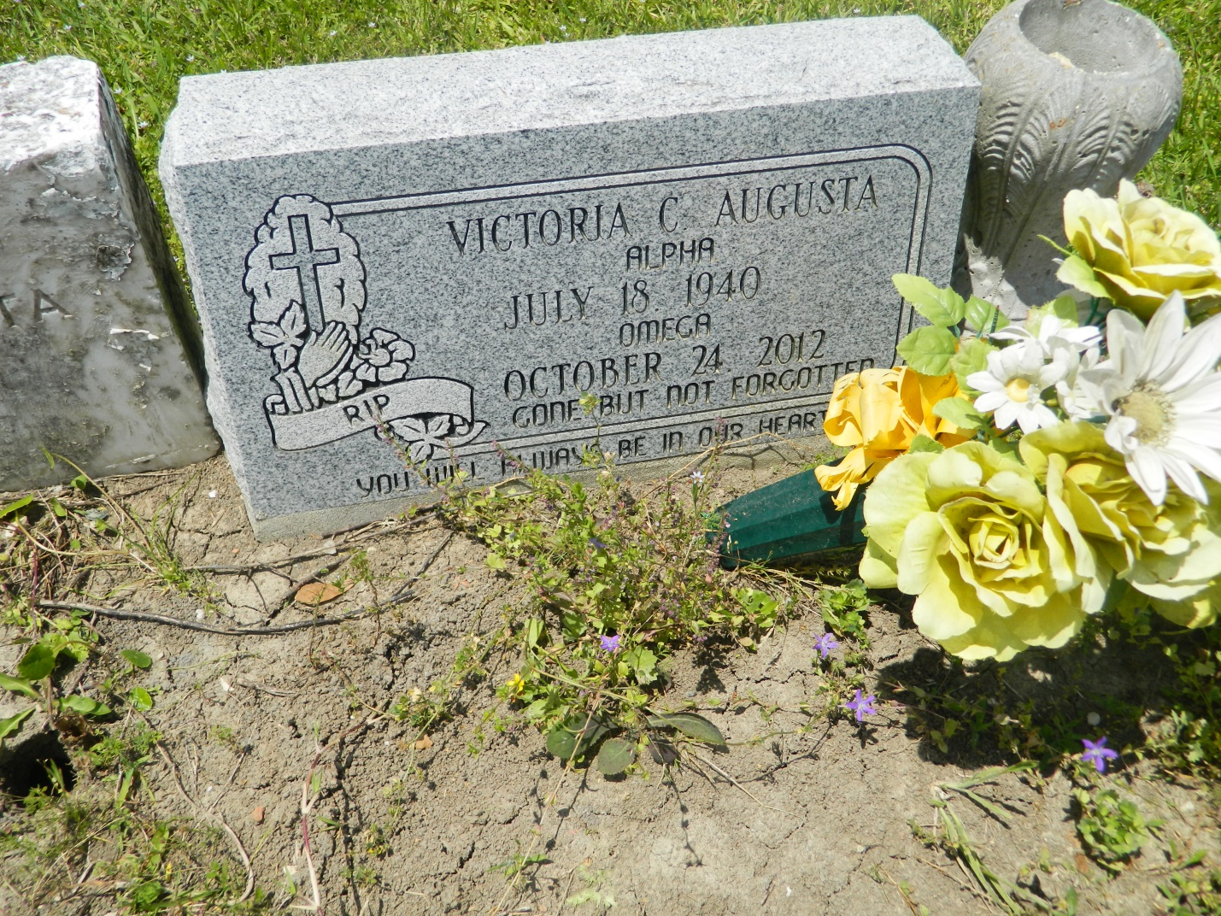

Victoria C. "Vick" Augusta at the age of 72 yrs. departed this earthly life on Wednesday October 24, 2012 at St. James Parish Hospital of Lutcher, LA. Beloved wife of Gene Augusta of Edgard, La. Loving mother of Victorine Hanson (Barry), Paulette Bornes (David), Patricia Melendez (Kevin), Reginia Augusta and Violet Bornes (Brian). Also survived by 7 brothers, 2 sisters, 13 grandchildren, 5 great-grandchildren and host of nieces, nephews other relatives and friends.  
  
Relatives and friends of the family also pastors, officers and members of Greater New St. Peter Baptist Church, New Jerusalem Baptist Church, From My Heart from Yours, Employees of Hampton Inn of Laplace, Ramada of Luling, Ormond Nursing Care Center of Destrehan, Walmart of Boutte, Comfort Inn and Suites of St. Rose, La. and Chateu St. James are invited to attend the funeral services on Saturday November 3, 2012 at 11:00am at Greater New St. Peter Baptist Church 200 W. 3rd St. Edgard, La. Rev. Vernon Alexander officiating Burial will be in the church cemetery. Visitation will be at the above name church from 9:00AM until service time.  
  
Bardell's Mortuary of Mt. Airy, La. in charge. Information: 985-535-6837

**Times-Picayune, The (New Orleans, LA) - Friday, November 2, 2012**

**Contributed by Jane Edson**