Aldonia (Bailey) Batiste

July 27, 1924 – April 2, 2010

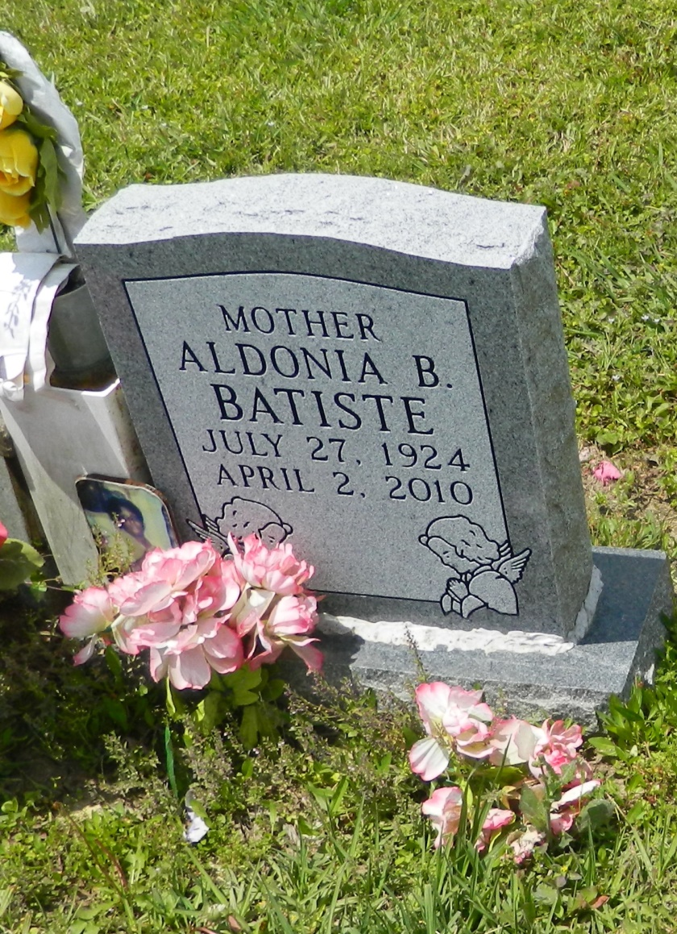

Aldonia "Babe" Bailey Batiste, of Edgard, LA, on Friday, April 2, 2010 at St. James Hospital entered eternal rest. Age 85. She was preceded in death by her parents, Antoine and Angelle Bailey; her siblings, Pearl Dumas, Antonio Alexander, Herman, Leroy and Rev. Joseph T. Bailey; her husband, Newton Baptiste; one son, August Batiste; one son-in-law, Wilfred Armant; and one daughter-in-law, Deborah Batiste. She leaves to cherish her memories, her 9 children: Senobia (Washington) Allen of Wallace, LA, Milton Batiste of LaPlace, LA, Cleola Pierre of Luling, LA, Ethel (William) Smith, RoseMary Armant, Brenda Borne, Eva, Winenell and Joann Batiste all of Edgard, LA. Also survived by 13 grandchildren, 19 great-grandchildren, a host of nieces, nephews, relatives and friends.  
  
Relatives and friends of the family, also pastors, officers and members of Second African Baptist Church, New St. Peter B.C., Antioch Baptist Church, Bethlehem Baptist Church, and all neighboring churches; and employees of Winn-Dixie and Alpine Plastics are invited to atend the Funeral Services on Thursday, April 8, 2010 at 11:00 a.m. from Second African Baptist Chuch, Edgard, LA. Rev. J. Weber, Pastor, Rev. C. Williams, officiating. Interment: Young Cemetery, Edgard, LA. Visitation will begin at 9:00 a.m.  
  
Baloney Funeral Home, LLC, 399 Earl Baloney Dr., Garyville, LA, Information: (985) 535-2540, in Charge of Arrangements.

**Times-Picayune, The (New Orleans, LA) - Wednesday, April 7, 2010**

**Contributed by Jane Edson**