Leana (Lewis) Bradley

March 23, 1932 – September 16, 2007

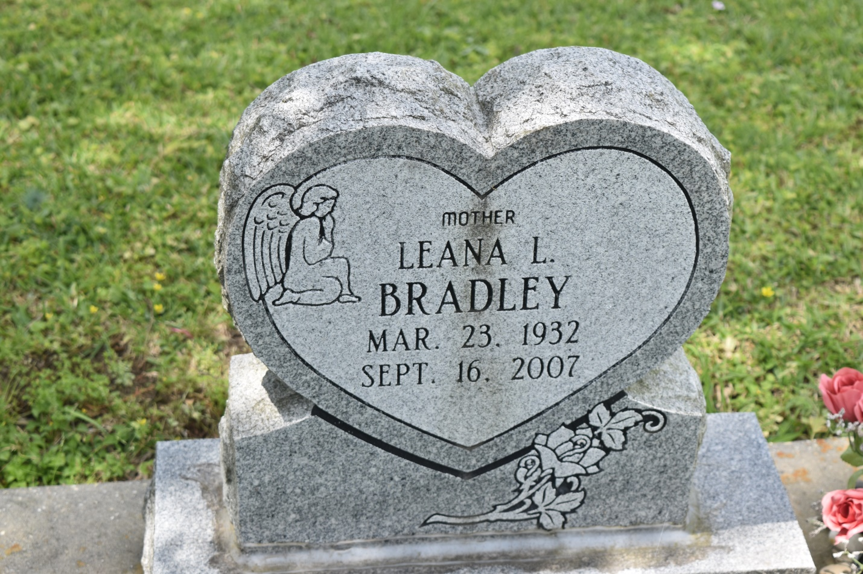

Leana L. (Ya-Yawn) Bradley, of Edgard, LA at River Parishes Hospital, entered the loving arms of Jesus on Sunday, September 16, 2007. Daughter of the late Albert John Lewis and Leontine Lewis. Wife of Nathan Bradley. Mother of Joyce Savoie (Craig) of Edgard, LA, Ella Mae "Shirley" Queen (Leroy) of Port Allen, LA and the late Arnold Dale Bradley. Grandmother of Carlo Savoie (Kimberly), Latasha Savoie Taylor (Donnell), Pamela Fontenot (Leo), Angela Brown (Chris) and Leroy Queen, Jr. (Nakita). Also survived by 9 great-grandchildren. Sister of the alte Alma Milton, Mary Grodon, Cora Grows, Leontine Lewis, Albert, Cloffer, Raymond, Clarence and Richmond Lewis. Survived by sisters-in-law: Vanita Lewis and Dorothy Lewis; a host of nieces, nephews, cousins and friends. A native and resident of Edgard, LA. Age 75 years.  
  
Relatives and friends of the family; also pastors, officers and members of the Morning Star B.C., New Jerusalem B.C. and neighboring churches are invited to attend the Funeral Services on Saturday, September 22, 2007 at 11:00 a.m. from the New Jerusalem B.C., East 6th St., Edgard, LA. Rev. Joseph Johnson, Pastor, Rev. Frank Johnson, officiating. Interment Young Cemetery, Edgard, LA. Visitation at the church after 9:00 a.m.  
  
THE BALONEY FUNERAL HOME, L.L.C., 399 Earl Baloney Dr., Garyville, LA 70051, Information: (985) 535-2540, IN CHARGE OF ARRANGEMENTS

**Times-Picayune, The (New Orleans, LA) - Friday, September 21, 2007**

**Contributed by Jane Edson**