Abbie Lynn (Milton) Gauthier
December 11, 1957 - September 8, 2023

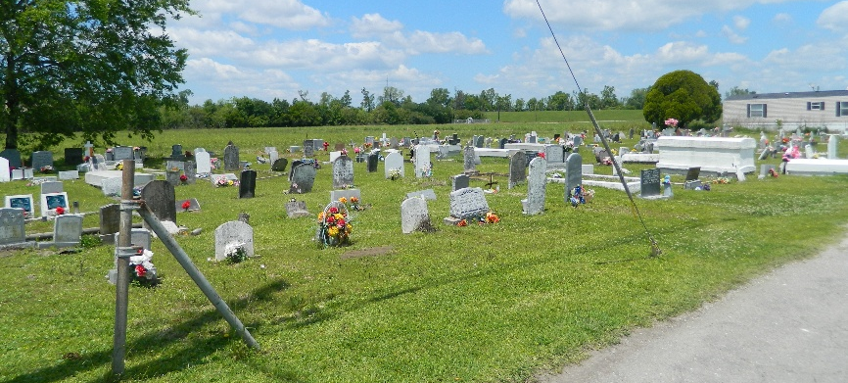

Abbie Lynn Milton Gauthier, age 65, transitioned from this life on Friday, September 8, 2023. She was born on December 11, 1957 in New Orleans, LA to Wilbert and Dorothy Milton. Abbie lived her entire life in Edgard, LA where she graduated from Second Ward High and went on to attend Meadows Draughon Business College.
She was a dedicated wife, mother, grandmother and great-grandmother. Abbie had a passion for hosting gatherings and bringing joy to others through her food and uplifting spirit. She instilled a sense of strength in each of her children and grandchildren. Abbie was a mother figure to many others in addition to her children and grandchildren. She never met a stranger and always left a lasting impression on everyone she encountered!
To cherish her memories, she leaves behind a loving and devoted husband, Allen Gauthier, Sr.; her children, Monique Gauthier Bechet (Terence), Allen Gauthier, Jr. (Chantrel), Mindy Gauthier Spears (Corey Spears, Sr.); seven grandchildren, Avery Gauthier, Alante Gauthier, Aston Bechet, Jade Bechet, Corey Spears, Jr., Camron Spears and Jordyn Bechet; one great-grandchild, Kinsley Roy and two siblings, Wilbert “Wayne” Milton (Cynthia) and Deselle Milton Gustain (Donell). She also leaves behind a devoted friend, Claudia Bailey and a host of nieces, nephews, relatives and friends.
Family and friends are invited to celebrate the life of Abbie Lynn Milton Gauthier on Monday, September 18, 2023, at New St. Peter Baptist Church, 200 W. 3rd St., Edgard, LA 70049. Visitation beginning at 9AM with services to follow at 10AM. Interment at Young Cemetery, which is also located on W. 3rd St.

Treasures of Life Funeral Services, Gramercy, Louisiana

