Enola (Smith) Grows
July 25, 1942 - August 18, 2024

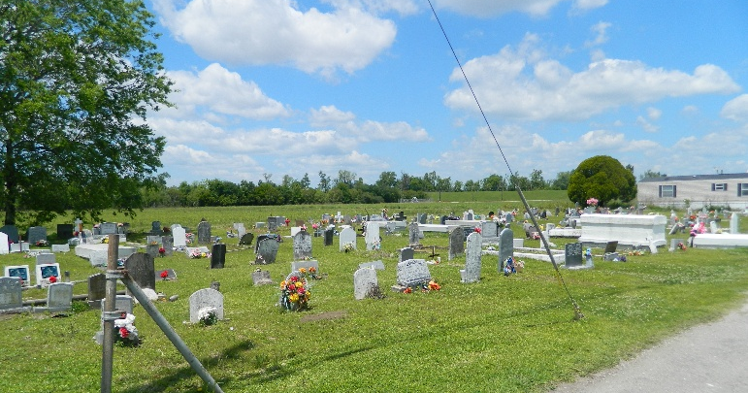

God ordained the birth of Enola “Red” Smith, the second of ten offspring born to the blessed union of the late Peter and Geneva Lumar Smith on Saturday, July 25, 1942. Enola was baptized at an early age in the Catholic faith at St. John the Baptist Parish Catholic Church of Edgard, La. She was later baptized at Greater New St. Peter Baptist Church by the late Rev. J.J. Harper. Enola was educated in St. John the Baptist Parish Public School System.
Enola and Calvin Grows Jr., became one as he promised to love, honor, and share his life with her before God on Saturday, February 27, 1960. Their union was favored with the birth of seven children: Lindy, Karl Sr., Timothy, Lisa, Calvin III, Bruce, and Bryant. She was affectionately known by the entire community as “Grandma Red.” Beloved for her delicious frozen cups and fierce spirit. Her preferred pastimes were cooking, sewing, shopping, and spending time with her grandchildren.
Enola peacefully departed earthly life for her eternal home early in the morning on Sunday, August 18, 2024, at her home. She was 82 years old. Beloved family members that preceded her in death were her parents, Peter Sr. and Geneva Lumar Smith; parents-in-law, Calvin Sr. and Luella Woodfork Grows; maternal grandparents, Eugene and Lucille Lumar; son, Bruce Grows; sisters Victoria Augusta and Katherine Farnell; brothers, William, Peter Jr., and Donald Smith, Sr.; brother-in-law, Gene Augusta; sister-in-law, Ethel Mae Smith.
Precious memories of her are forever embedded in the hearts of her loving husband of sixty-four years, Calvin Grows, Jr.; daughters, Lindy and Lisa Grows; sons, Karl Sr. (Jeanenne), Timothy, Calvin III, and Bryant (Joycelyn) Grows; her 11 grandchildren, 14 great grandchildren, brothers, Curtis, Wilfred, Harold and Nathaniel Smith; sisters-in-law, Loretta and Marshelia Smith; godchildren, Dolores Louis Harrison, Danny Antonio, and Camille Roussell, Jr.; dear friend, Frances Bovie; many nephews, nieces, cousins, friends, and neighbors.
A celebration honoring her life will be held on Saturday, August 24, 2024, at Greater New St. Peter Baptist Church, 200 W. 3rd St., Edgard, La. 70049. Visitation period begins for 9 am followed by service for 11 am. Interment at Young Cemetery.

Treasures of Life Funeral Services, Gramercy, Louisiana
August 22, 2024

