Evelyn Grows

Abt. 1941 – November 26, 2019

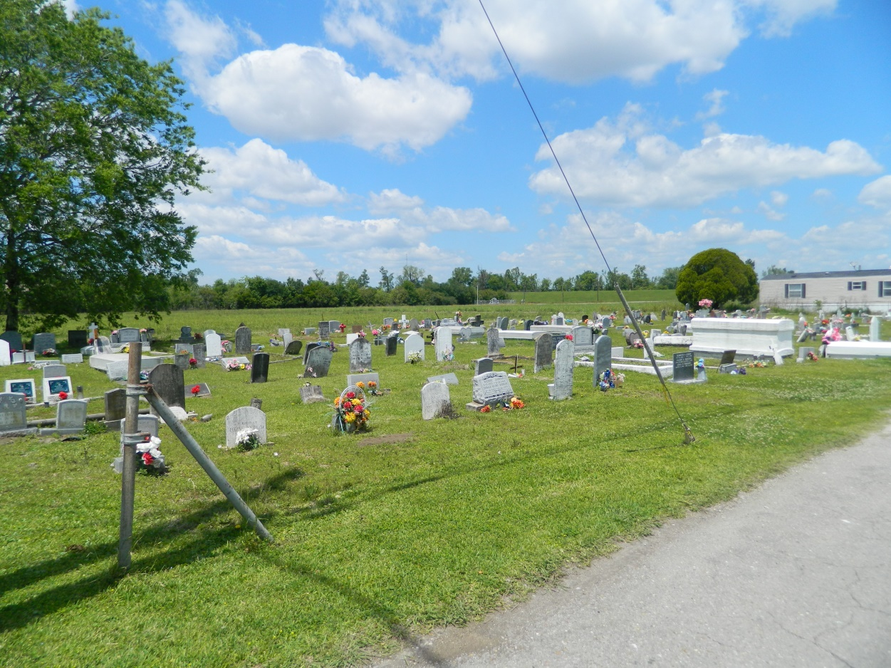

Evelyn "Monte" Grows, at the age of 78 years, departed this Earthly life at Ochsner Hospital of Kenner, LA on Tuesday, November 26, 2019. Daughter of the late Louis and Cora Lewis Grows. Loving mother of Ronald, Troy, Francis, and the late Brice Grows. Sister of Elouise Stockman, Dorothy Smith, Annie Mae Populis, and Francis Grows. Also survived by a host of nieces, nephews, other relatives, and friends. A resident of Edgard, LA. Evelyn was preceded in death by her parents, Louis and Cora Lewis Grows; her siblings, Amelia Narcisse, Eula Mae Narcisse, Walter Sr (Gloria), Morris (Shirley), Oscar (Late Aldonia), Melvin (Clementine), Lawrence Sr. (Marion), and Ellis Sr (Constance). Pastors, officers, and members of Second African Baptist Church of Edgard, LA, St. Mark Baptist Church of Mt. Airy, LA, Young Pilgrim Baptist Church of Convent, LA, Mt. Carmel Baptist Church of New Orleans, LA, and all neighboring churches are invited to attend the homegoing celebration on Friday, December 6, 2019 at 11:00a.m. at Second African Baptist Church, 130 West 3rd St., Edgard, LA. Pastor Clarence C.Z. Molliere officiating. Interment in Young Cemetery of Edgard, LA. Visitation: Thursday at Bardell's Mortuary of Mt. Airy, LA from 3:00 p.m until 6:00 pm and at the above name church from 9:00 a.m. until service time. Bardell's Mortuary in charge.

Published in The Times-Picayune (New Orleans, LA) on Dec. 5, 2019