Shirley Mae (Favorite) Grows
July 18, 1938 - March 14, 2024

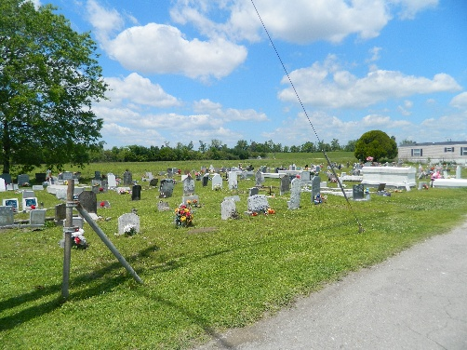

Shirley Favorite Grows departed this life at her residence on March 14, 2024, at the age of 85. Wife of the late Morris Grows. Devoted mother of Ricky Grows, Avis Batiste, Donna Numa (Roger), Gregory Grows (Bonnie) and the late Angela Grows. She was the daughter of the late Samuel Sr. and Virginia Favorite, and daughter-in-law of the late Louis and Cora Grows. Shirley was the sister of Margaret Henderson, Geraldine Boose, Vivian Chopin, Larry Favorite, and Anna Lewis. Godmother of Jacqueline Sorapuru, Darrin Favorite, and Betty Marshall. Shirley is also survived by 11 grandchildren, 23 great-grandchildren, 5 sisters-in-law, 2 brothers-in-law, and a host of nieces, nephews, cousins, other relatives and friends.
A public visitation will be held on Friday, March 22, 2024, at Treasures of Life Funeral Services, 325 East Airline Hwy., Gramercy, LA 70052 from 3PM-5PM. Relatives and friends of the family, also Pastors, officers and members of the Greater New St. Peter Baptist Church and all neighboring churches, employees of Targa Resources, St, James Arc, and St. John the Baptist Parish Schools are invited to attend the funeral services on Saturday, March 23, 2024, at 11AM, held at Greater New St. Peter Baptist Church, 200 West 3rd St., Edgard, LA 70049. Visitation begins at 9AM. Rev. Joseph Comminie, officiant. Interment to follow at Young Cemetery in Edgard.

Treasures of Life Funeral Services, Gramercy, Louisiana
March 20, 2024

