Walter Grows Sr.

June 1, 1931 – July 31, 2008

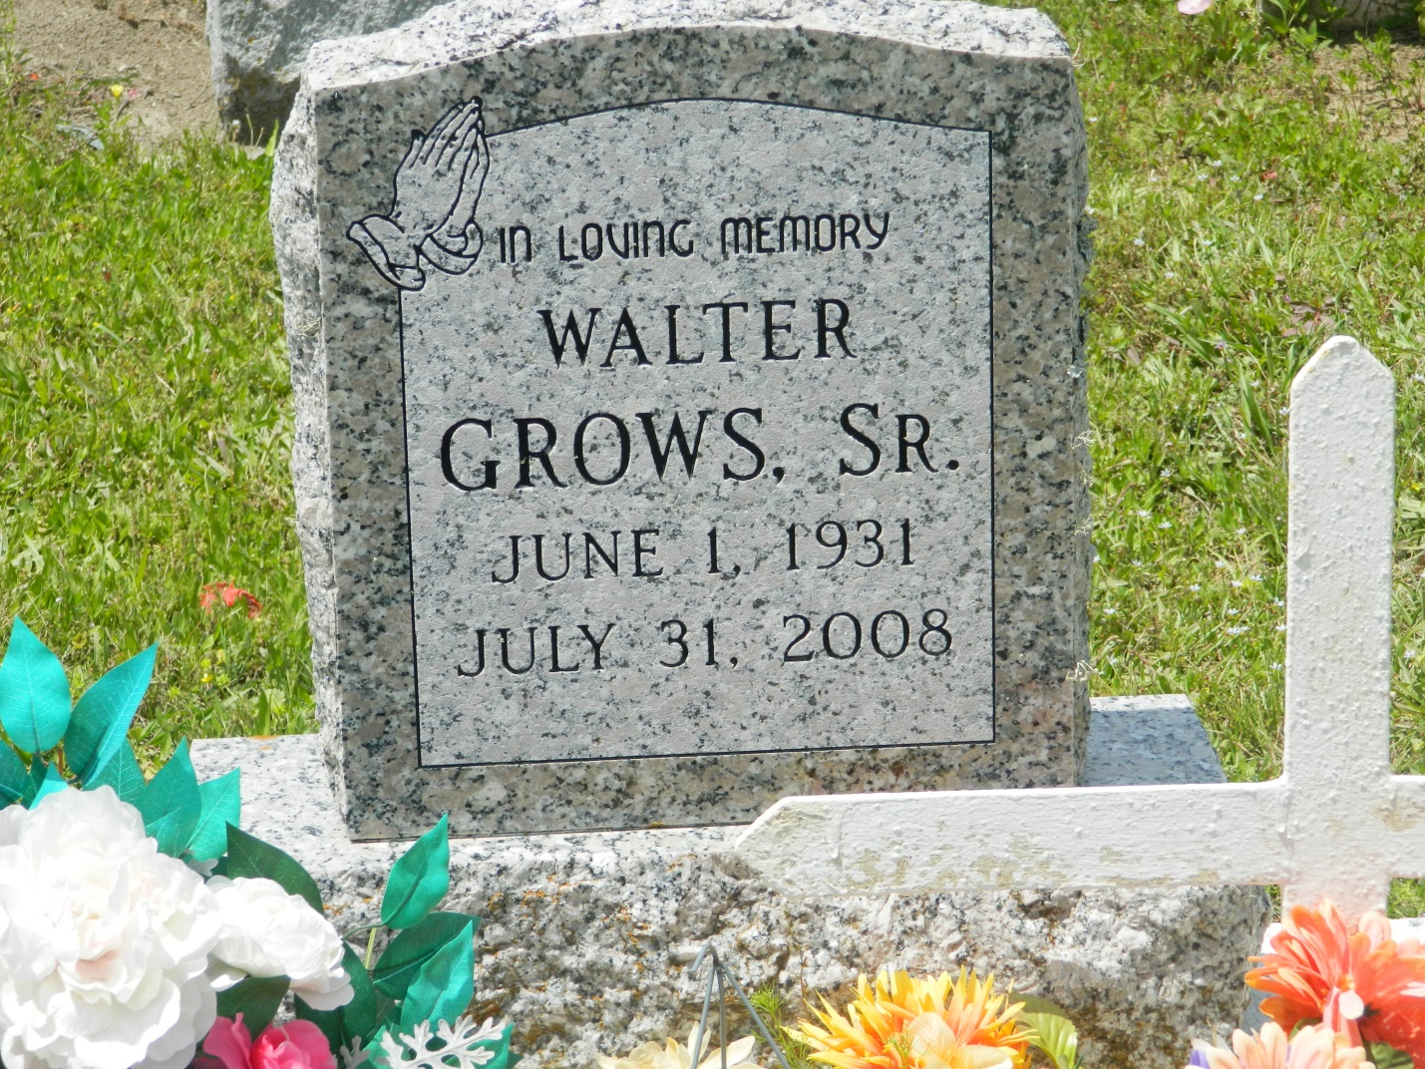

Walter "U-Ta" Grows Sr., 77, died July 31, 2008. The Edgard native and resident was son of the late Louis and Cara L. Grows Sr., beloved husband of Gloria Mae Herbert Grows, father of Janice Rhea, Michael Grows and Walter Grows Jr., brother of Amelia Narcisse, Evelyn, Lawrence Grows, Elouise Stockman, Dorothy Smith, Eula Narcisse, Annie Mae Populis, Francis Williams and the late Morris, Melvin, Ellis Sr. and Oscar Grows.  
  
Also survived by seven grandchildren, four great-grandchildren, three brothers-in-law, 10 sisters-in-law and a host of nieces, nephews, cousins and friends.  
  
Relatives and friends of the family, also pastor, office and members of the second African Baptist Church, Bethlehem Missionary Baptist Church, Woodville Baptist Church, St. Phillip Catholic Church, Greater New St. Peter Baptist Church and neighboring churches. Employees of Nephology Association/Metropolitan Kidney Center, DOW Chemicals SCO and Pepsi Americas are invited to attend the funeral services on Wednesday, August 6, at 11 a.m. from the Second African Baptist Church, 136 W. 3rd St., Edgard, La., Rev. Joseph Weber officiating. Interment Young Cemetery, Edgard. Visitation at the church after 9 a.m.

**L'Observateur (La Place, LA) - Tuesday, August 5, 2008**

**Contributed by Jane Edson**