Russell Jack Sr.
February 27, 1950 - April 4, 2025

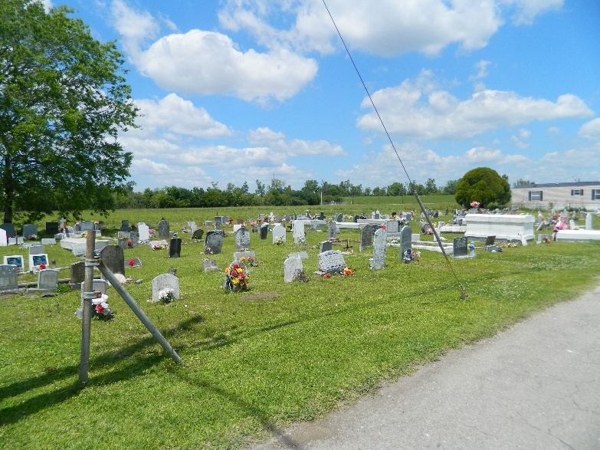

Russell Jack Sr. was born to Ervin Jack Sr. and Eliza Johnson on February 27, 1950. Russell was the 4th of 5 children. His grandmother, “MaMa Rose” played a significant part in rearing him into adulthood. At an early age, Russell secured his eternity with the Lord by accepting Jesus Christ as his personal savior. He was baptized at New Jerusalem Baptist Church in Edgard, LA. by the late Reverend Clarence Albert Washington. As a faithful member of the church, he later joined the male choir.
Russell received his education in the public schools of St, John the Baptist Parish and was a graduate of the Second Ward class of 1969. He later attended welding school where he received his First-Class Welding Certification. Russell was a hard worker and worked in various industries throughout the River Parishes such as Avondale, Dow, Carbide, and Shell, just to name a few. He worked tirelessly to support his family.
Russell was united in holy matrimony to the late Laverne Jasmine on December 3, 1970. From this union, three children were born: Donyel “Trixie” Jack Baldwin of Houston, Texas, Russell “Jack” Jr., and Travis Jude Jack (Arielle Hurst). Russell was a simple man who lived a simple life. It didn’t require much to make him happy. He had a huge heart and loved his family, friends, and classmates dearly. He was the proudest of his children and their accomplishments. He was well known in his beloved community, and everyone would agree that an encounter with “Strong” was one to remember. Whether he was blessing you with one of his funny one-liners, pinching you to remind you he loves you, or transporting you as the neighborhood Uber driver, he never met a stranger.
On Friday, April 4, 2025, Russell peacefully slept away at his home. God granted him his wish. Three scores in ten. As he would say, “I was born in Burlywood and I’m going to die in Burlywood.
Russell leaves to cherish his memory: Three devoted children, Donyel Jack Baldwin (Anthony), Russell Jr., and Travis (Arielle). 5 grandchildren, Alexia, Eric Jr., Harleigh, Harper, and Travis Jr. His siblings; Ervin Jack (Dianne), Preston Jack Sr. (Patricia), Hayward Jack (Judy). Sisters-in-law; Shirley Thomas, Myrtle Walker, Betty Franklin (Zachary), Alicia Wright (William), Rona Thomas, Shelia Morris, Joyce Thomas (James), Denise Mason, Donita Bell, Tammy Sorapuru (Rudolph), La’Duanne Gautier, and Dyuanne Trench (Shawn). Brothers-in-law; Thomas Jasmine ll (Shirley), Alton Jasmine, Nathaniel Jasmine (Lischelle), Frazier Tompkins lll, and Eric Bourgeois, John A. Wright Jr., Mark Wright Sr. (JoMarietta), David Wright (Toni), Ronnie Torregano, Bruce Borne, Lawrence Borne Jr. (Myra), Tommy Borne (Druhetta), Brian Borne, and Desmond Borne (Deon). One goddaughter; Tricia Young. Devoted friend; Lionel Campbell, and Devoted cousins; Wayne Johnson, Betty Lou Boudoin, and Belinda Powell amongst a host of others.
Russell was preceded in death by his wife; Laverne Jack, his parents; Ervin Jack Sr., and Eliza Johnson Jack. His grandparents; Barthalomew “Papa” and Lena “MaMa” Johnson Sr., Aunts; Viola Jackson, Lorenza Lorio, Louiza Smith, “Sister”, and “Girl”. Uncles; Jimmy Johnson, Ernest Johnson, Willie Johnson, Jesse Johnson, Arthur Johnson, and Clarence Johnson. His mothers-in-law; Orelia “Bea” Wright, Geraldine Borne, and Lillian Jasmine. Fathers-in-law; Lawrence Borne Sr., John A. Wright Sr., and Thomas Jasmine Sr. and his Sister; Talnay Jack. Sisters-in-law, Leola and Leander Jack, Enola Allen, Janice Lumar, Marion Feast, Linda Samuels, Cynthia Thompkins, Madeline Bourgeois, Josalyn Gastearl, and Valerie Torregano. Brothers-in-law; Antoine Jasmine, Anthony Samuel, Anthony Gastearl Sr., John Walker, Johnny Allen, Wilbert Thomas Sr., Alex Lumar, Carlos Morris, Clinton Wiltz, Devoted nephew; Lamonth Jack. Cousin; Jackie Lorio, and Dearest friend; the late Ellis “Biscuit” Hall Sr.
We would like to give special thanks to these remarkable individuals, David Johnson, Morell Bartholamew Sr., Devrin Johnson Sr., Lawrence Johnson Jr., Wendell Downing, and Shane Gautier, who went out their way to ensure our dad was well taken care of.
Family and friends are invited to honor Russell's life during a public visitation on Friday, April 11, 2025 at New Jerusalem Baptist Church, 152 E. 6th Street, Edgard, LA 70049 from 5:00pm to 7:00pm. A second public visitation will be held on Saturday, April 12, 2025 from 8:00am to 11:00am at New Jerusalem Baptist Church, 152 E. 6th Street, Edgard, LA 70049; followed by a Celebration of Life beginning for 11:00am. Interment Young Cemetery, W. 3rd Street, Edgard, LA 70049.

Treasures of Life Funeral Services, Gramercy, Louisiana
April 10, 2025

