Cosey Lewis Jr.

October 15, 1940 – January 11, 2008

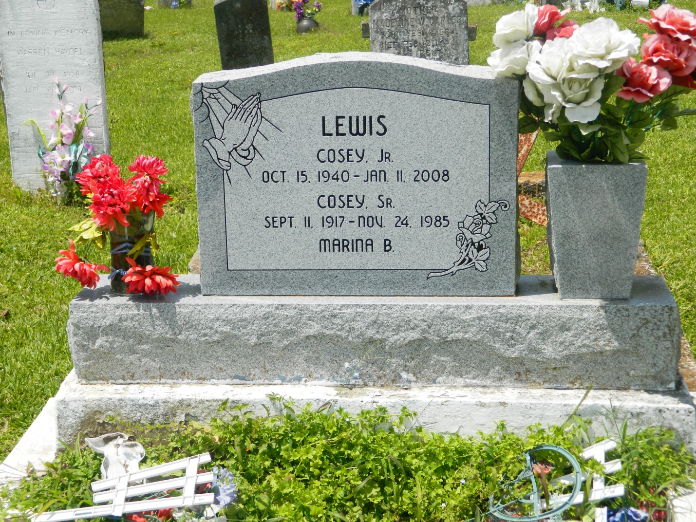

Cosey "Winky" Lewis, Jr., age 67 years, departed this life at his residence in Edgard, LA on Friday, January 11, 2008. Co-owner of Westside 66 of Edgard, LA. Beloved husband of Marion F. Lewis. Son of the late Cosey Sr. and Marina Lewis. Father of Conrad (Denise) Lewis, Shawn (Charlotte) Lewis, Robin Lewis, Brandie (Rhondele) Williams and Jason Lewis all of Edgard, LA. Brother of Haston Lewis, Sr., Marion Wyre, Henry Lewis and Marlis Lewis. Devoted uncle of Sharlene Wyre. Also survived by 16 grandchildren, 6 brothers-in-law, 9 sisters-in-law, a host of nieces, nephews, cousins, other relatives and friends.  
  
Relatives and friends of the family; also pastors, officers and members of the Greater New St. Peter B.C., 2nd African B.C. and all neighboring churches; employees of St. John Sheriff Office, St. John Parish Courthouse, Avondale and Entergy are invited to attend the Funeral Services on Thursday, January 17, 2008 at 11:00 a.m. from the 2nd African Baptist Church, W. 3rd St., Edgard, LA. Rev. Joseph Weber, Pastor, Rev. Vernon Alexander, officiating. Interment Young Cemetery, Edgard, LA. Visitation at the Church after 9:00 a.m.  
  
THE BALONEY FUENRAL HOME, L.L.C.  
  
399 Earl Baloney Dr., Garyville, LA 70051  
  
Information: (985) 535-2540  
  
in charge of arrangements

Times-Picayune, The (New Orleans, LA) - Wednesday, January 16, 2008

**Contributed by Jane Edson**