Steve Lewis Sr.

August 29, 1924 – December 3, 2010

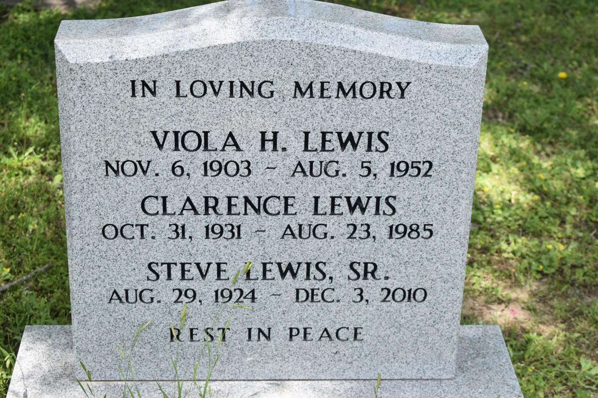

Steve Lewis, Sr. on Friday, December 3, 2010 departed this life at Touro Infirmary. Beloved husband of Laura Mae Lewis. Son of the late Terrence Lewis Sr. and Viola H. Lewis. Father of Steve Lewis, Jr., Ethel Mae Hickman of Tacoma, WA, Rozelia Johnson and Solomon Lewis, Sr. Brother of Corita L. Taylor, Alexander Lewis, Terrence Lewis, Jr. Viola Singletary of Stanton, CA, Ernest Sterling Lewis of Springfield, IL and the late Rene and Clarence Lewis, Helen Knows, Flocy Wise, Lucille Howard and Sedonia Givens. He is also survived by 4 grandchildren, 10 great grandchildren and a host of nieces, nephews, other relatives and friends.  
  
Relatives and friends of the family, also Pastors, Officers and members of Greater New St. Peter B.C., Henderson Bible Church, Greater St. Stephen F.G.B.C., Third Rose of Sharon B.C. and Second African B.C. are invited to attend a visitation service on Saturday, December 11, 2010 from 8:00 AM until 9:00 AM at Rhodes Chapel, 3933 Washington Ave. A funeral services at 11:00 AM at Greater New St. Peter B.C., West 3rd Street, Edgard, LA. Visitation will be from 10:00 AM. Interment: Young Cemetery.  
  
Arrangements by Rhodes Funeral Home.

**Times-Picayune, The (New Orleans, LA) - Friday, December 10, 2010**

**Contributed by Jane Edson**