Thelma (Grows) Lewis

April 18, 1928 – October 28, 2007

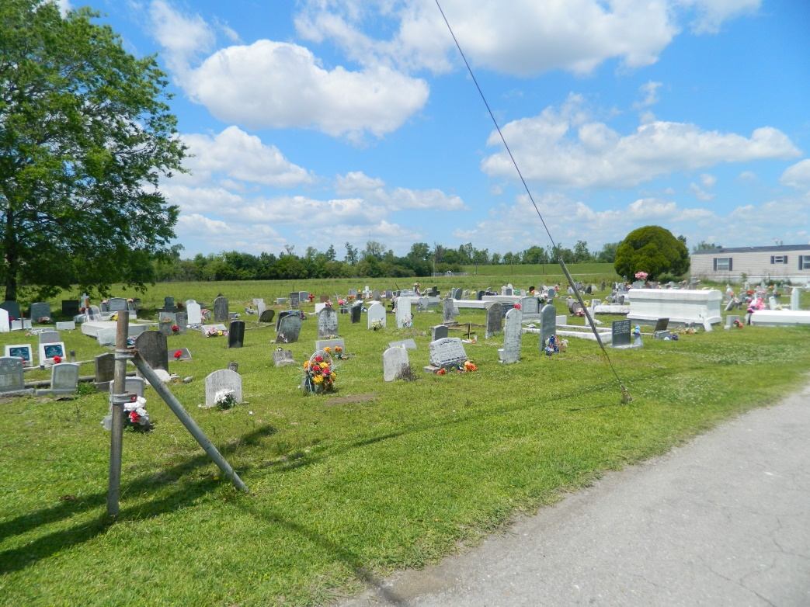

On the early morning of Sunday, October 28, 2007, at the age of 79, Thelma Grows Lewis gently passed away to her eternal home to be joyously welcomed by her beloved husband, Junius Lewis, Jr.; her daughter, Mary Jane Lewis; sons: Harold Martin and Peter James Lewis; her ward, Cory Grows; father, Joseph Grows, Sr.; mother, Everlina Stockman Grows; sisters: Lena and Laura Grows, Hilda and Beulah Bailey, Stephiner Dumas; and brother, Clarence Grows. Mother of Allen Lewis, Sr. (Diana) of Reserve, Lionel Lewis, Sr. (Sherial) of Laplace, Audrey Howard (Hyford) of River Ridge, Betty Jackson (Michael) of Mt. Airy, Janice Stewart (Gregory) of Vacherie, Amelia Swiffey (Tony) of Laplace, and Sheryl Lewis of Baton Rouge; 2 brothers: Joseph Grows, Jr., Edgard and Lionel Grows, Sr. (Debra) of Algiers.; 2 sisters: Amy Narcisse (Alfred) of Edgard and Mildred Clark (Charles) of Raytown, MO, 2 brothers-in-law: Ronald Dumas of Vacherie and James Lewis of Vacherie; 1 sister-in-law, Dorothy Lewis of New Roads, LA, 16 grandchildren, 6 great-grandchildren, 1 godchild, Donna M. Lewis, a host of nieces, nephews, other relativeds and friends.  
  
Relatives and friends of the family, also employees of Family Home Care, St. James Parish Hospital, River Parish Hospital, Edgard, Senior Citizens Center, Golden Link Society, St. John Parish Public Works, Vincent Rollo Security, Luling Living Center, Diagnostic Imaging Service, End Zone, Ormond Living Center, Deluxe Cleaners, are invited to attend Funeral Services at Second African B.C., West 3rd St., on Saturday, November 3, 2007 at 11:00 A.M. Visitation at 9:00 A.M. Rev. Joseph Weber, officiating. Interment Young Cemetery, Edgard, LA.  
  
The Baloney Funeral Home, LLC, 399 Earl Baloney Dr., Garyville, LA 70051, Information: (985) 535-2540, In Charge of Arrangements.

**Times-Picayune, The (New Orleans, LA) - Friday, November 2, 2007**

**Contributed by Jane Edson**