Arthur Howard Louis
December 25, 1954 – November 20, 2024

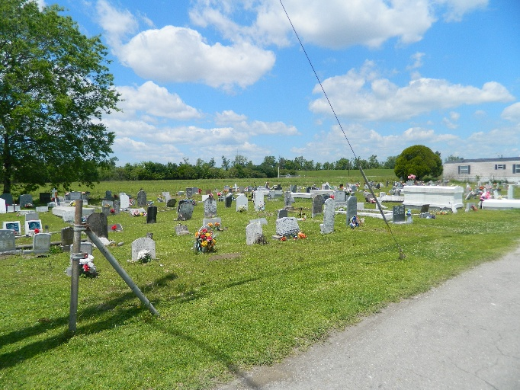

On Wednesday, November 20, 2024. Arthur Howard Louis age 69, of Edgard, La., peacefully entered eternal life. He was born on December 25, 1954 to the late James Louis Sr. and Wilverine Howard. Arthur, affectionately known as Nunney, was a Graduate of Second Ward High, Class of 1973. Arthur was the devoted husband of Norma Louis. Father to Jagen Louis; Britt Coleman; The late Trent Louis, of Edgard, La. Grandfather of Jalaya Coleman. God father of April Howard and Zinna Duppard. He was a successful operator at St. John the Baptist Parish Utilities.
He is survived by his wife Norma Louis, children Jagen Louis and Britt(Wayne) Coleman. Granddaughter Jalaya Coleman; siblings Clarence Louis (Connie) of Wallace, La., Mary Simon (late Melvin) of Vacherie, late Michael Lewis Sr. (Romona) of Edgard, Gene Lewis (late Denise), of Edgard, LA; Valerie Smith (late Byron) of Wallace, La. James Louis, Jr. of New Orleans, La. Daughter-in-law Javier Borne. A host of aunts, uncles, nieces and nephews.
Visitation will be held on Friday, November 29, 2024, at Treasures of Life Funeral Services, 315 E. Airline Hwy., Gramercy, LA for 2:00 p.m. to 4:00 p.m. A Celebration of his life will be held on Saturday, November 30, 2024 at New St. Peter Baptist Church, 200 W. 3rd Street, Edgard, LA for 11:00 a.m., with a viewing for 9:00 a.m. until service time. Interment to follow at Young Cemetery, 200 W. 3rd St., Edgard, LA.

Treasures of Life Funeral Services, Gramercy, Louisiana
November 26, 2024

