Gerilyn Ann Mitchell

December 9, 1990 – February 18, 2010

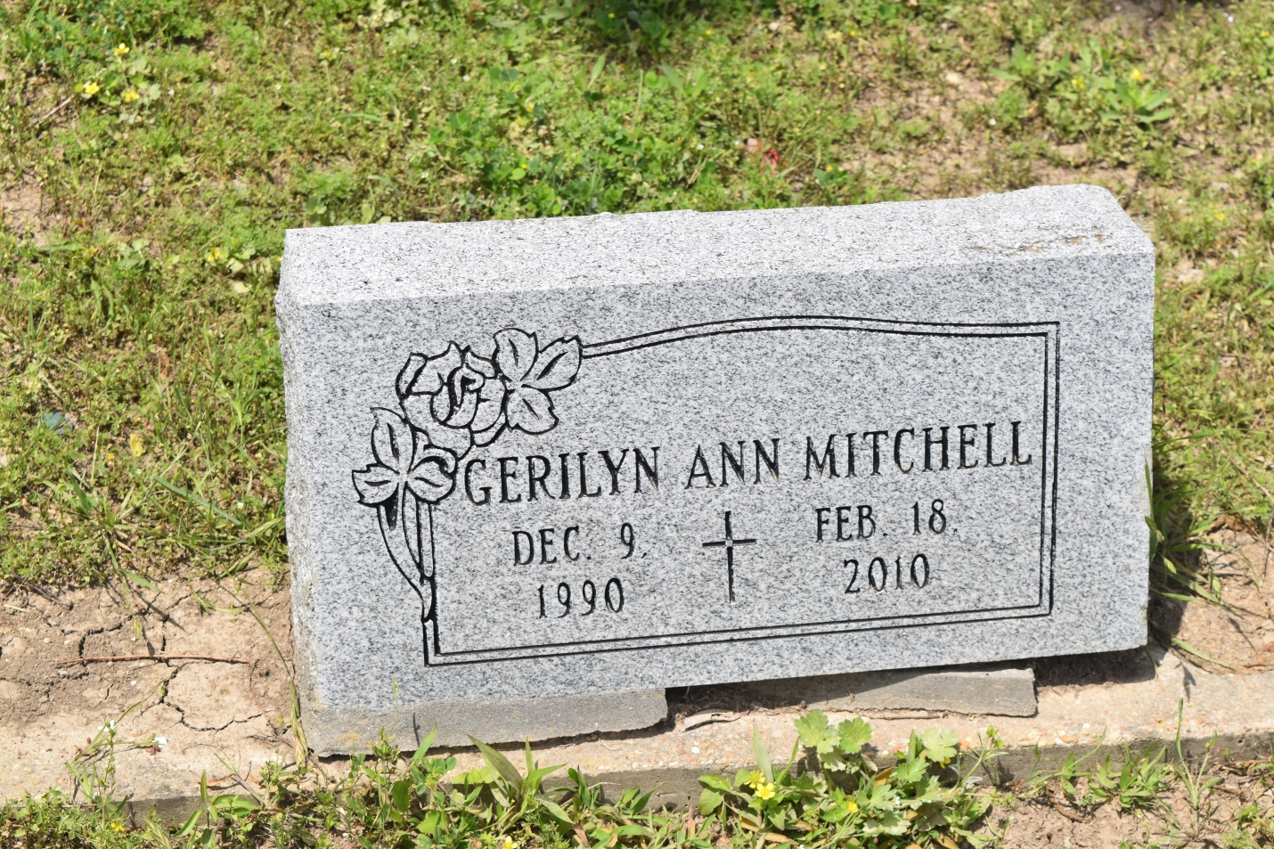

Gerilyn Ann (GG) Mitchell, of Edgard, LA, on Thursday, February 18, 2010 at Ochsner Foundation Medical Center. Daugher of Rodney Lewis and Oliska Mitchell. Sister of Reva. Kayla, Rodney, Dwight, Alonzo, Montel, Isiah, Jordan and Gabrielle. Granddaugher of Clarence Lewis and the late Juanita Lewis, Audrey Mae and Irvin Mitchell. Survived by a devoted aunt, Valerie L. Howard and a host of other aunts, uncles, cousins and friends. A native and resident of Edgard, LA. Age 19 years.  
  
Relatives and friends of the family, pastor, officers and members of St. Peter B.C., faculty and staff of East St. John High School Class of 2010 are invited to attend the Funeral Services on Saturday, February 20, 2010 at 1:00 p.m. from the St. Peter B.C., Edgard, LA. Rev. Vernon Alexander, officiating. Burial Young Cemetery, Edgard, LA. Visitation at the Church after 8:30 a.m.  
  
The Baloney Funeral Home, LLC, 399 Earl Baloney Dr., Garyville, LA, Information: (985) 535-2540, in Charge of Arrangements.

**Times-Picayune, The (New Orleans, LA) - Saturday, February 20, 2010**

**Contributed by Jane Edson**