|  |
| --- |
|  |
|  |

Joseph Narcisse

Abt. 1973 - February 22, 2014

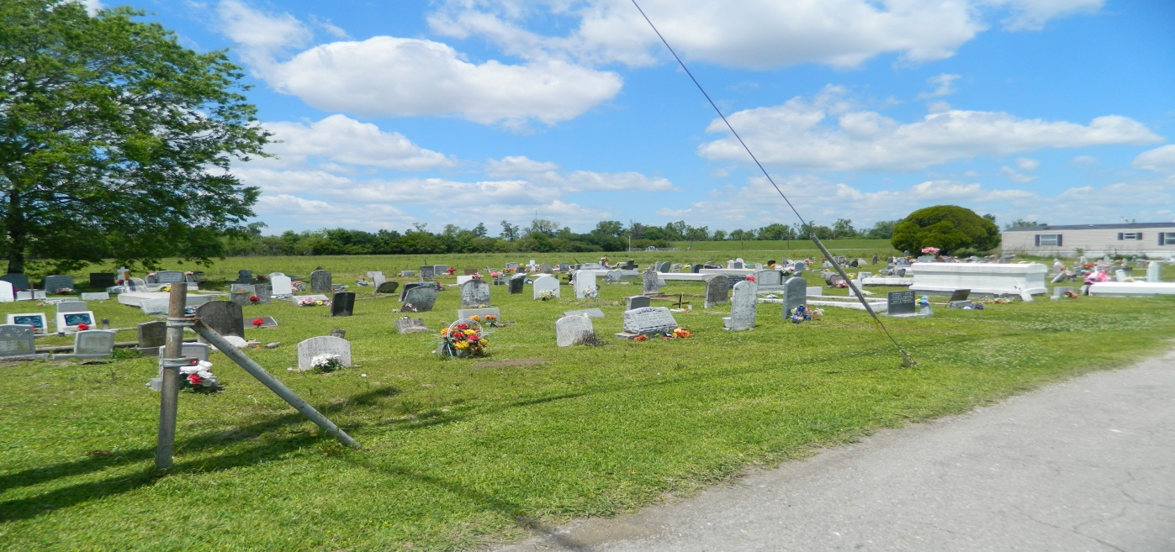

JOSEPH NARCISSE passed on Saturday, February 22, 2014 at East Jefferson General Hospital, Metairie, LA. Son of Curbit Narcisse and the late Amelia Grows Narcisse. Brother of Francis Locket, Diane, Curtis, Clifford, Calvin, Debra, Joanne, Maryann and Charlene Narcisse, Cheryl, Alvin, Eric, Derrick and David Sims. Also survived by a host of nieces, nephews, cousins, other relatives and friends. Age 41 years. A native of St Rose, LA and a resident of Kenner, LA.

**Unknown source**