Alodia (Poche) Pierce

October 29, 1911 – September 26, 2009

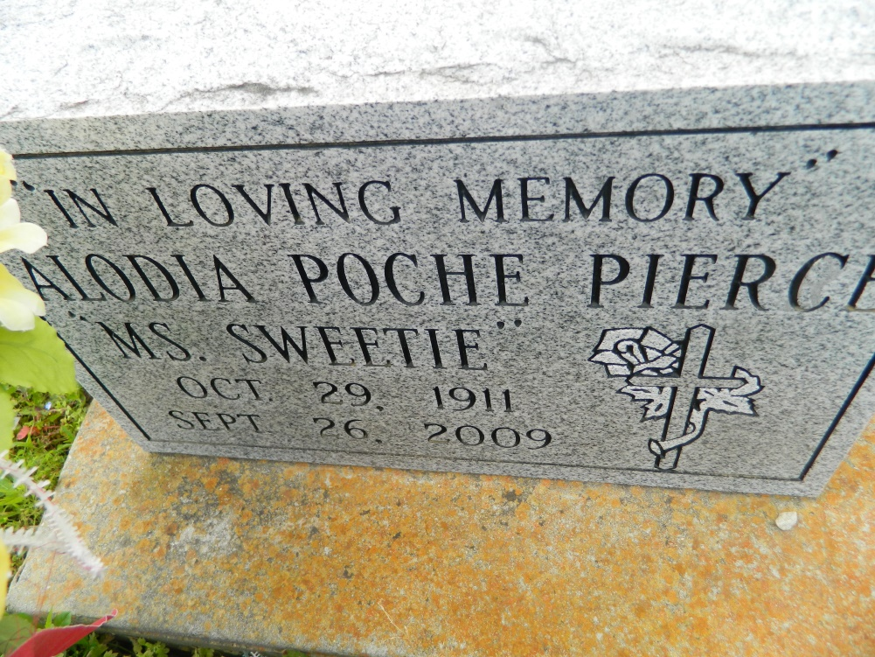

Alodia Poche Pierce passed away on Saturday, September 26, 2009 at Saint Elizabeth Hospital in Gonzales, La. She was 97. She was the beloved wife of the late Alexander Pierce. She was the daughter of the late Joseph and Idel Poche. She was the mother of Claudia (late Royal Burke) Alcus (Linda) Pierce, Celina Haydel, Augustine (Ronnie) Brown, Odeal (Allen) Milton, Lawrence (Gwinette) Pierce, Dolores Pierce and the late Thomas, Rufus, Alex, Herbert and Corinne Pierce. She was the sister of the late Angelle Bailey, Josephine Weber, Viola, Celina, Laura, Odeal and Eddie Poche. She is survived by a host of grandchildren, great-grandchildren and great-great-grandchildren. Devoted caregiver Barbara Batiste. A host of nieces, nephews, other relatives and friends.  
  
Relatives and friends of the family, also Pastor, Officers and members of the Second African Baptist Church, Greater New St. Peter Baptist Church, St. John the Baptist Catholic Baptist Church, and neighboring churches, employees of Cajun Construction, Entergy, Dow Chemicals, St. John Parish Police Department, ADM, St. John the Baptist Parish School System, St. James Homecare, Vacherie Personal Care System are invited to attend the funeral service on Saturday, October 3, 2009 at the Second African Baptist Church, Edgard, La., at 11:00 A.M. Reverend Joseph Weber officiating. Interment Young Cemetery, Edgard, La. Visitation after 9:00 A.M. on Saturday.  
  
The Baloney Funeral Home LLC, 399 Earl Baloney Dr., Garyville, La., 985-535-2540 in Charge of Arrangements.

**Times-Picayune, The (New Orleans, LA) - Friday, October 2, 2009**

**Contributed by Jane Edson**