Elvira (Lewis) Pierce

January 24, 1909 – Mary 28, 1977

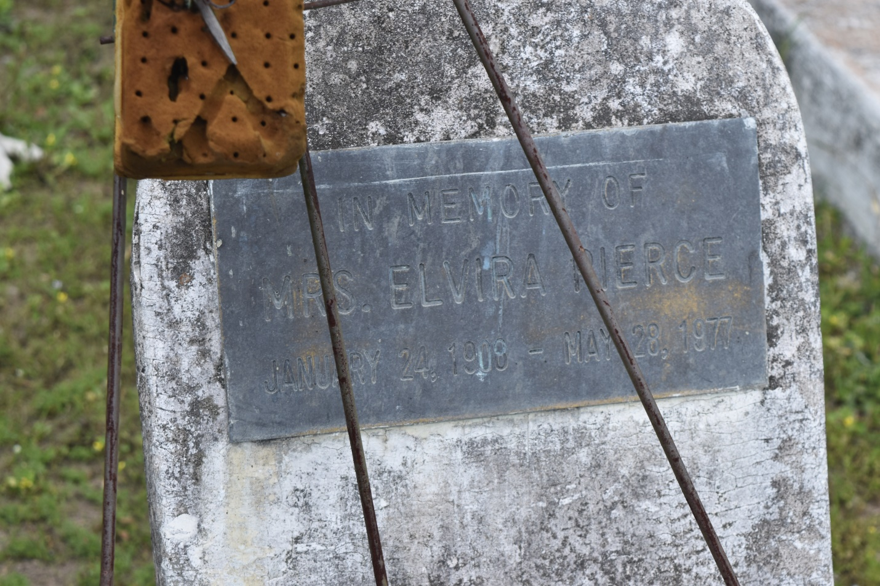

Elvira Lewis Pierce, at Charity Hospital, in New Orleans, on Saturday, May 28, 1977, at 6 o’clock p.m., daughter of the late Abraham and Sophie Lewis, beloved wife of Hillary Pierce Sr., mother of Hillary Pierce Jr., sister of Coazy and Clarence Lewis, and the late Elvira, Joseph, Abraham, Alfred, Columbia, and Haston Lewis; mother-in-law of Theresa Pierce, grandmother of Hillary III, Steve and Danny Pierce; great-grandmother of Trina, Nagtone, and Danielle Pierce; also survived by 2 grand=daughters in-law, 12 sisters-in-law, 10 brothers-in-law, and a host of nieces, nephews, other relatives and friends, a native of Edgard, La.

Relatives and friends of the family, also pastors, officers and members of St. Joseph, Israel, Beautiful Zion, Little Zion, First Zion Baptist Churches, Second African Baptist Church of Edgard, La., and all neighboring Churches, are invited to attend the funeral and wake services at St. Joseph Baptist Church, 7731 Olive Street, on Friday, June 3, 1977 at 8 o’clock p.m. Rev. C.J. Allen officiating. Dismissal services on Saturday June 4, 1977 at 11 a.m. from the above named Church. Motorcade to Edgard, La., where the body will be viewed at Second African Baptist Church, pastored by the Rev. Joseph Baily.

Interment in Young Cemetery, Edgard, La. Williams Funeral Home, 3101 Pine Street in charge of arrangements. Bill Williams Funeral Director.

**The Times-Picayune (New Orleans, Louisiana); Friday, June 3, 1977, Page 18**